

GENG5506 – Group Design Project

GENG5506 - Renewable Energy

**Lecturers:** Dr. Binayak Banerjee, Mr. Behnam Taherian and Dr Hossein Nabavi, **Unit Coordinator:** Prof. Victor Sreeram

**Due:** 4th November 2016 5PM

Word Count: 3801

Team Members:

|  |  |  |
| --- | --- | --- |
| **Last Name** | **First Name** | **Student Number** |
| BARDZOVSKI | Steven | 21121998 |
| BASSON | Elzenic | 21111387 |
| CATTACH | Miles | 21124567 |
| CONRADIE | Thomas | 21127771 |
| MCKINLEY | Anthony | 20758849 |
| PIETERS | Francois | 21200276 |

Document history:

|  |  |  |  |
| --- | --- | --- | --- |
| **Version** | **Comments** | **Date** | **Author** |
| V1.0 | Initial draft. Headings and styles – general layout | 24/10/16 | T. Conradie |
| V1.1 | Modelling/Simulation for ‘Load’ and ‘Base’ done. | 24/10/16 | T.Conradie |
| V1.2 | Wind, Wave and Hydro | 25/10/16 | T.Conradie |
| V1.3 | Project Planning section and relevant appendices. Update $/kwh | 25/10/16 | T.Conradie |
| V1.6 | Remove serval figures from ‘Load’, ‘Base case’ and ‘Wind/Wave’ | 2/11/16 | T.Conradie |

# Table of Contents

Table of Contents 3

Nomenclature 4

1 Executive summary 5

2 Introduction 5

3 Literature Review 6

3.1 Solar PV 6

3.2 Wind 6

3.3 Tidal 6

3.4 Wave 7

3.5 Batteries 8

3.6 Compressed Air 8

3.7 Pumped Hydro 9

4 Business case 10

5 Project Planning 12

6 Modelling and simulations 12

6.1 Load 12

6.2 Base Case (Generator only) 16

6.3 Wind, Wave and Pumped Hydro 17

6.4 Photovoltaic, Wind and Battery 22

6.5 Summary and Comparison 25

7 Technical and economic feasibility 26

7.1 Wind, Wave and Pumped Hydro 26

7.2 Photovoltaic, Wind and Battery 26

7.3 Summary and Comparison 26

8 Environmental constraints and future prospects 27

9 Personal Reflection 29

10 References 35

Appendix A – HOMER Simulation reports 38

Appendix A1 – Base case simulation report 38

Appendix A2 – Wind, Wave and Pumped Hydro simulation report 42

Appendix A3 – PV, Wind and Battery Storage simulation report 48

Appendix B - Project Planning 54

Appendix B1 - Meeting minutes 54

Appendix B2 - Gantt Chart / Project Timeline 58

# Nomenclature

|  |  |
| --- | --- |
| BESS | Battery Energy Storage System |
| HOMER | Hybrid Optimization of Multiple Energy Resources |
| NPC | Net present cost |
| PV | Photovoltaic (not to be confused with Present Value which is used to calculate NPV) |
| PHES | Pumped Hydroelectric Storage |
| CAES | Compressed Air Energy Storage |

# Executive summary

*“Describe the high level design and feasibility of the project in*

*approximately 300 – 500 words.*”

# Introduction

One of the biggest challenges that modern society currently faces is how to successfully transition from fossil fuel to renewable power generation. This transition is necessary because the current rate of fossil fuel consumption is not sustainable. Conservative projections estimate that coal reserves will be depleted in 100 years and oil in only 50 [1]. Naturally, different projections vary across quite an extensive range. However, there is very little doubt about the severity of the current scenario.

In order to procure effective solutions to the problem of depleting fossil fuel reserves, society needs to act on a global scale. In 2014, renewable energy contributed approximately 23% of global electricity production [2]. It is currently the fastest growing source of world energy with consumption increasing by roughly 3% every year [3]. There are several reasons for the increased interest expressed in renewable energy sources. The recent concerns over the volatility of oil prices, the dependency on foreign energy sources, and the environmental consequences of carbon emissions are all contributing factors [3].

Additionally, government policy is a major driver of renewable energy development [2]. Policies such as tax credits, installation rebates, portfolio standards and the establishment of markets for renewable energy certificates have been critical in the promotion of the technology [3]. The Federal Government of Australia currently has a scheme in place entitled The Renewable Energy Target (RET) which aims to double the current levels of renewable energy production by the year 2020. If this target is achieved, approximately 23.5% of Australia’s electricity generation in 2020 will be from renewable sources [4].

This report aims to investigate the technical and economic feasibility of different renewable energy sources and storage methods. Two alternative system designs are chosen based on the information gathered from an in-depth literature review and consideration of the setting in which the system will be installed. These two systems are then simulated and the results are compared.

# Literature Review

This section presents the findings of extensive research carried out by the group. First, the 4 types of renewable generation are presented: solar PV, wind, tidal and wave. Following that, the 3 types of storage available are investigated: batteries, compressed air and pumped hydro.

## Solar PV

Along with wind, solar photovoltaics (PV) is currently one of the fastest-growing renewable energy sources. The massive growth that solar technology has experienced since the nineties can be largely attributed to the various market support programs implemented through governmental policies [5]. Because Australia has higher average solar radiation per square metre than any other continent in the world, solar energy has massive potential as a future source of electricity generation in this country. There have also been monumental leaps in the energy conversion efficiency of solar cells over the past few decades. The first silicon solar cell was reported in 1941 and had less than 1% energy conversion efficiency compared to the 25% efficiency of modern times [6].

However, as solar power generation becomes more commonplace, the inherent intermittency of the solar resource poses one of the great challenges to those who would design and implement the next generation smart grid [7]. Not only does the variable nature of the solar resource itself introduce challenges, but the way in which solar PV generation is distributed throughout the grid is also an issue.

The price of photovoltaic (PV) systems has dropped precipitously in recent years, led by substantial reductions in global PV module prices [8]. It has actually been discovered that the increasing installation trend and decreasing price trend are related to one another and leads to a kind of Moore’s Law of PV systems. At present rates, the cost of PV systems halves approximately every 10 years [9].

## Wind

For centuries humans have been harnessing the power of the wind from agriculture to science and even exploration [10]. Since the late 1800s energy in wind has been used to produce electricity and today wind energy is one of the leading sources of renewable energy. Power in the wind is proportional to the density and cubed velocity of the wind, which means that even small increase in wind speed can cause a great increase in the power the wind possesses. Wind turbines are used to convert the wind energy into electrical energy. They consist of 2 or 3 blades that sweep a circular area. As the wind passes the blades the different densities below and above the blades cause them to rotate. This rotation turns a generator which produces the electricity, which is then sent to the desired loads. Wind turbines can be placed both onshore and offshore, with offshore being the more favourable of the two due to the fact that there is more space and higher winds in the oceans.

The cost of wind energy has decreased over the past 30 years due to the improvement in turbine technologies and increase in efficiencies [11]. There are two main costs attributed to wind energy; capital costs and variable costs. Capital costs include the manufacturing and installations of wind turbines including all transportation costs (of materials) and transmission lines. Variable costs refer to the costs attributed to operation and maintenance of the wind turbines and also land rent, employee salaries and insurances [11]. Levelized cost of energy (LCOE) is an agreed upon method used to assess the value of a project. To calculate the LCOE of a wind energy system the yearly cost of generating energy is divided by the annual energy production [11]. The LCOE of offshore wind turbine projects have been higher than those of onshore wind turbine project. On average offshore wind projects are more expensive than onshore projects, however, there is a change in this trend and it is predicted that offshore wind turbine projects will decrease by nearly 45 % with only a 25 % reduction in onshore wind turbine projects [12].

## Tidal

Tidal forces are variations in gravitational acceleration, causing water levels to change in large bodies of water mostly due to the orbiting pattern of the moon around earth. The fluctuating water levels causes water shores to experience water flow toward shore on a rising tide and away from shore on a falling tide [13].

All of the methods of tidal power generation utilise the natural cyclic nature of the tides, however there are different ways in which the energy of the tides can be harnessed and converted into electrical energy. Dunlap [14] breaks the tidal generation methods into two major types, barrage and non-barrage. With the non-barrage methods having several sub types of generation techniques.

*Barrage*

Barrage systems generate power by damming water during a tide extremity and after half a tidal cycle making use of the potential energy created when the water levels are different on either side of the dam [13]. At this point the potential energy is converted into kinetic and electric by allowing the water to flow from high to low spinning turbines positioned along the wall as the water is released at a controlled rate, producing the required amount of power. This method can only produce power at 25% of the total capacity factor due to the equalling water levels when flow is allowed and due to the unidirectional nature of this method. The total capacity factor can be increased however using ebb generation schemes as noted in Sustainable Energy [14].

Barrage systems have been the most popular systems in the past, due to their simplicity, however the ecological impacts these systems have on ecosystems and habitats have been realised recently. The tidal fluctuations are no longer natural when a barrage system is implemented, water flow rates are drastically altered and in many cases the migration of water based animals are impossible [15]. These reasons and more are why the non-barrage systems have been implemented for newer systems, in order to have less of an impact on the environment while still generating renewable energy from tidal energy.

*Non-Barrage*

Tidal Lagoons: Functionally these systems work the same as barrage systems, however these lagoon systems are manmade and are often circular in shape, allowing for animals to swim from upstream to downstream and having minimal impact on ecosystems on the neighbouring shorelines. These systems are often used bidirectionally, discharging a stored high tide during a receding tide and allowing an incoming tide to flow into the stored low tide water levels. These systems tend to have a higher setup and maintenance cost when compared to the simple barrage systems [14].

Underwater Turbines: Unlike the barrage and tidal lagoon systems, underwater turbines don’t generate energy from the potential difference due to tides, but the kinetic energy in the tidal currents. These systems don’t use the high current turbines like the previous systems but use slower rotating larger diameter blades similar to wind turbines [14]. These underwater turbine systems allow for farms to be setup consisting of a number of individual underwater turbines which allow for future expandability depending on the power demand. Ecologically these turbines offer limited negative effects, with the biggest impact being an open spinning blade, potentially harming animals, however the slow rotational velocity of the turbine reduces the likelihood of the event occurring [16].

Tidal Fences: These generation systems are set up similarly to a barrage but operate vertical turbine columns which are bidirectional, allowing for a 50% total capacity factor. However, these are very new systems and no large scale systems have yet been implemented [14].

## Wave

Wave Power is the technique of extracting energy from the Ocean’s waves in order to generate electricity. One of the defining features of wave power is the huge efficiency available – many existing systems and patents or concepts are capable of above 80% efficiency of transferring the wave power into energy, however most commercial installations are operating around 40% [17]. However, its inconsistency and lack of competitiveness to other types of renewables: huge investment and fast economic recovery period of Wind, Solar and more recently Tidal have curbed investment in to the technology. Wave power is entirely reliant on the wind to create the currents that cause the waves in the ocean, the inconsistency of wave patterns has been a huge detractor in investment and made wave power systems significantly riskier.

There are 5 prevailing types of wave energy capture. There are a few others but they have not yet been attempted to be commercialised and are still in the concept stage. The existing solutions are listed below [18]:

1. **Point absorber buoy** – A buoy sits on the water surface, connected to a support on the seafloor, the rise and fall from swell is used to drive hydraulic pumps to then generate electricity. These are best suited a long distance away from shore.
2. **Surface attenuator** – These are similar to the point absorber buoy, the difference being that they sit in a line connected to each other on the water surface capturing energy. Although considered a different type to point absorber buoy, in effect it is a different arrangement/application of the same thing.
3. **Oscillating wave surge converter** – The least commonly used type, the oscillation of the float sitting on the water connects to the fixed point on the sea floor, this energy is captured and transferred onshore.
4. **Oscillating water column** – An air turbine is driven by the wave and swell motion; large amounts of noise energy is produced.
5. **Overtopping device** – The velocity of the waves fills containers to higher than the wave level, the potential energy from the rise of the water is then used to drive low hydraulic-pressure turbines.

The large amount of money required for R&D still makes the true cost of a wave energy system hard to truly quantify. The only measurable cost for a recent project in WA, and as such highly relevant, is the $100,000,000 AUD 2016 Carnegie Wave Energy 5 MW system, of which only 1.5 MW is currently operational [19].

The other relevant example is the Aguçadoura Wave Farm, which was constructed in 2008 but taken offline a few months later due to friction bearing issues, this plant cost $11.5 Million USD (~$16 Million AUD 2016) for only the generation equipment [20]. It is not thought that this plant will ever become operational again. Overall, the cost is most likely the biggest current issue with Wave Energy; it is a hard sell when cheaper, lower risk options already exist.

## Batteries

Batteries are the longest and most used form of energy storage with the need growing more prevalent with the increase in use of renewable resources. Lead-acid batteries, invented in the 1900’s, are the most mature and commonly used type of rechargeable battery. Lead-acid batteries have efficiencies is typically 70 - 90 percent with an expected lifetime of 5-15 years [21]. The advantages of these batteries are that they are reliable, tolerant to overcharge and cheap [22]. Disadvantages being that lead is toxic, heavy, cannot tolerate ‘fast charge’ and has a limited life cycle.

Electronic systems have been using Lithium-ion batteries for over 40 years and are being implemented to replace Lead-Acid technology for backup power supplies and grid applications [22]. The high energy density, low self-discharge and high efficiency are commonly used in portable devices and electric vehicles. Their efficiency ranges from 85-98% and has a lifetime of about 5-15 years [23]. The main disadvantage of this technology is due to the energy density and combustibility of lithium, cells are at risk of overheating which can lead to fires [24].

Recently, within the past 20 years, Lithium Iron Phosphate (LFP) batteries have been discovered and developed. In WA, currently many companies are investing in research to confirm manufacturer claims of this technology [25]. LFP technology is expected to have over twice the cycle life and is much less prone to thermal runaway then previous Lithium-ion technologies, this means improvements in terms of cycle life and energy density [25].

## Compressed Air

Compressed Air Energy Storage (CAES) systems are used as a form of energy storage. Off-peak electricity to compress air, which is stored in underground caverns or storage tanks [26]. This air is later released to a combustor in a natural gas turbine to generate electricity during peak periods. Efficiency typically ranges between 45 and 70 percent. CAES commonly used commercial bulk energy storage plants as it is a relatively mature and cost effective technology. Large underground caverns for the storage of the air along with non-renewable natural gas generators are the disadvantages of CAES technology [23].

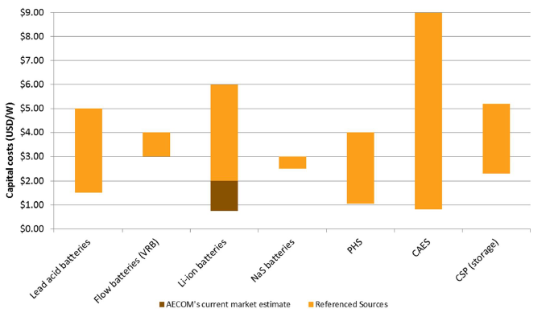

Figure 1: Capital Costs in USD/kWh of different storage technology [26]

## Pumped Hydro

The drive towards wind and solar photovoltaic (PV) power generation systems over recent years has brought to light the need to store excess energy. In many ways, the biggest impediment to the widespread success of wind and PV technology is the fact that peak power generation takes place when the demand for electricity is not at a peak. To manage this challenge, a means of storing excess energy in times of peak generation and releasing it on demand when power consumption is at a peak, needs to be implemented. [27]

The energy storage methods considered in this report include battery, compressed air and pumped hydroelectric storage (PHES). This section summarises previous literature relating to PHES. After giving a brief background and summary of its operation, the discussion will focus on the costs and benefits of pumped hydroelectric storage (PHES).

Using water reservoirs as a means of energy storage dates back to 1890 in Italy and Switzerland. However, it was only in the 1960s to 1980s that PHES grew in popularity due the rapid growth of nuclear power after the 1970s oil crisis. [28] While PHES and conventional hydropower plants have strong similarities, the key difference is that pumped hydro has two reservoirs and the direction of water flow can be changed. In contrast, conventional hydroelectric plants only have one reservoir and the direction of water flow cannot be reversed [29].

Figure 2 illustrates the basic operation of a PHES system. When energy is being stored, the turbine is run as a pump to transfer water from the lower to the higher reservoir. This increases the potential energy of the water. To generate energy, water is allowed to flow from the high reservoir to the low reservoir by the force of gravity, hence losing potential energy. The kinetic energy gained by the water as it flows from the high to the low reservoir drives the turbine, hence generating electrical energy. [29] [30] [31]

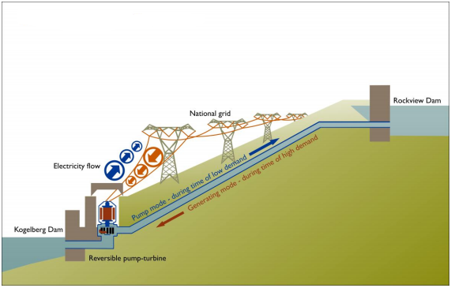

Figure 2: Pumped Hydroelectric Energy Storage System [32].

While PHES technology currently accounts for the bulk energy storage technology in a global sense [33], no large-scale applications have been implemented in Australia for the last 30 years [34].

In recent years, researchers have tried to address the environmental impact of PHES. Some have proposed underground reservoirs or the use of abandoned mines to avoid the deforestation and loss of land associated with building large reservoirs [35].

The cost of PHES systems vary greatly depending on the scale of implementation and the suitability of the site. In [36] a detailed cost estimate for a PHES system is discussed specifically focusing on an application in Australia. Typical initial outlays range between US$500 and US$1500 per kW rated output, however some projects have reported costs of up to $4000 per kW [36]. Considering the units of energy stored by these systems, the initial outlay amounts to about $100 to $200 per kWh [37].

# Business case

Based on the research conducted in the literature review, the following table of advantages and disadvantages was compiled:

Table 1: Advantages and Disadvantages of the Technologies Researched

|  |  |  |
| --- | --- | --- |
| **Technology** | **Advantages** | **Disadvantages** |
| **Solar PV** | * Australia has an extremely high amount of incident solar radiation. * Industry experiencing a lot of growth. | * Doesn’t produce power at night. * High temperature lowers cell efficiency. |
| **Wind** | * Power can be obtained from the wind at any time of the day. * Wind is present all over the world. | * Large areas are needed for wind farms as the location of each turbine in the wind farm must be far enough as not to hinder the efficiency of other turbines. |
| **Tidal** | * One of the few renewable sources which can be forecast. * Tides are constantly flowing and can thus produce power on a consistent basis. | * Can be very disruptive to ecosystems. * They require specific site requirements and must not encroach on existing societies or delicate environments. |
| **Wave** | * Capable of very high efficiencies. * Like the tidal resource, it can be predicted. * Western Australia has good conditions for wave energy. | * The components used in wave power systems are much rarer than other renewable energies. * The formation of waves depends on multiple variables such as the position of the moon and the direction of wind flow. |
| **Batteries** | * Would mitigate the problems caused by the variability of renewable generation sources. * Currently receiving lots of research and development, as well as lots of monetary investment. | * Battery technology is currently very expensive. * If batteries are not disposed of correctly, they can cause harm to the environment. |
| **Compressed Air** | * Provides a good way to store electricity during off-peak periods. | * Requires large caverns for storage of the air. * Capital costs are considerably higher than other storage options. |
| **Pumped Hydro** | * Controllable, reliable and stable (offers demand matching). * Long term reliability. If properly maintained; a system can last decades. | * Highly site-dependant. PHES is financially impractical in sites where largescale landscape remodelling has to be done. * Large reservoirs may cause deforestation, loss of wildlife and agricultural land. |

The table compiled above was a good starting point for the selection of the 2 options which would be investigated. In the first meeting, the team was unsure about what the best and worst technologies were. That is why it was decided to first complete the literature review and then gather for further discussion. After meeting several times to discuss the available options, the 2 options selected for simulation were:

-Wind, Solar and Batteries.

-Wind, Wave and Pumped Hydro.

There were of course many different combinations the team could have gone with, but in the end, it was decided that the first step should be to try and find the best possible combination of technologies. Once this combination was finalised, the second option would be composed of the best technologies left over.

Justification for Design 1: Wind, Solar and Batteries

Out of the 4 options for generation, the group unanimously agreed that solar and wind were much better than tidal and wave. This was based on the fact that solar and wind are proven renewable energy technologies, while tidal and wave energies require more development before they become viable options. This is understandable when one considers that tidal and wave are much newer technologies than solar and wind.

It particularly makes sense in an Australian context to select solar because of the high amount of solar radiation incident on the country. The spatial requirements of both solar and wind are not really that much of a challenge for Australia either, with vast masses of open land available for use.

The group initially elected to use solar in both design options, however a considerable weakness of solar energy is that it isn’t available at night. In the future, battery technology will undoubtedly gain prominence. However, both the cost and efficiency of battery systems for renewables sources need to improve before the technology is truly accepted. The investment in solar photovoltaics will definitely benefit from improving battery technology because the ability to store the power generated during the day would be very convenient.

Based on the fact that the wind resource is available at all hours of the day, the team resolved to use it in both design options. Wind power is the single fastest-growing renewable energy on the market as well, which adds extra credibility to its selection.

When it came to the question of which type of storage should be implemented in the best design, the group had little doubt that batteries were the answer. Battery technology is currently receiving a lot of investment, and will definitely be a common feature in future grid operation. A testament to this is South Australia’s recent unveiling of plans to build a 100megawatt battery storage unit.

Justification for Design 2: Wind, Wave and Pumped Hydro

While it was relatively easy to decide on the components of Design 1 because it involved using the best options available, Design 2 was much harder to finalise. It was obvious that wind would have to be used again because it is a much more proven technology than both tidal and wave. The big question for the team was how to decide between tidal and wave (the only remaining options). The team didn’t think either source of generation was very reliable, but had to select one of them for the purpose of this project.

After conducting the literature review, it was discovered that Western Australia is one of the few places in the world which is operating a large-scale wave power system. Located in Garden Island, the wave energy system is rated at 5MW. The fact that such a powerful wave farm was connected to the grid (a world-first) right off the coast of Perth is certainly an indicator that wave power is a viable option. Thus, wave power was selected instead of tidal.

One important point worth mentioning is the fact that both sources of generation in Design 2 depend on the presence of favourable wind. In the absence of strong wind, both the wind turbines and the wave farm would have a low output power. In comparison, Design 1 would perform well because an absence of wind wouldn’t affect the output of the solar panels.

Finally, a decision had to be made about the type of storage that would be implemented in Design 2. Since batteries could not be used a second time, the choice came down to either compressed air or pumped hydro. Research conducted in the literature review revealed that there are massive capital costs associated with compressed air technology. In addition, there are not many mines or caverns which can be utilised in close proximity to the specified location. As a result, pumped hydro was chosen.

# Project Planning

In the first team meeting, the concern was raised that most team members had very busy schedules. This meant that some team members may not be able to attend all meetings. To manage this challenge and to mitigate the risk of miscommunication an agreement was made that meeting minutes are to be documented in each meeting and distributed to all team members. One such document can be found in Appendix B1. This tool gave the team a structured way of documenting the decisions reached in each meeting along with the actions need to be taken before the next meeting. To ensure a structured flow of progress, the team placed emphasis on setting clear deadlines and ensuring that task assignments are clear.

Another project management tool used throughout the project was a project timeline. The Gantt chart in Appendix B2 outlines all the projects task, deliverables, milestones, and task progression. The timeline also indicates task interdependencies as well as the work groups or individuals assigned to particular tasks. As with most project timelines, the Gantt chart is dynamic in nature and task assignments and start dates had to be modified and adapted as the project progressed.

# Modelling and simulations

This section discusses the simulation and modelling procedures that were followed to analyse the proposed design along with the alternative wind, wave and pumped hydro design. By comparing the simulation results against the base case where the existing generator is the only means of energy generation, the proposed and designs will be evaluated. All simulations were carried out in HOMER which claims to be the global standard in microgrid software [38]. HOMER is specifically designed to simplify the task of designing hybrid renewable microgrids and aids the process of simulation, optimization and sensitivity analysis.

To facilitate meaningful comparisons between the proposed design and the alternatives, each system has to be simulated under the same load. Section 6.1 will summarise the load that was used in each simulation. Before considering alternative strategies, the existing case was simulated as described in Section 6.2. Next, in Section 6.3 a wind, wave and pumped hydro scenario is investigated followed by the simulation of the proposed system in Section 6.4. Finally, in Section 6.5 a summary and comparison is provided between the cases that were simulated. All simulations were carried out over a 25 year period as summarised in Table 2.

|  |  |
| --- | --- |
| **Simulation Parameters** | |
| Software | HOMER |
| Duration | 25 years |
| Discount Rate | 8% |
| Location | Crawley, WA |

Table 2: Simulation parameters for all simulations

## Load

The first component of the modelling and simulation carried out in this investigation is the load. The systems proposed here are being designed to accommodate a remote community in Western Australia which has a daily energy demand of 10MWh and a peak demand of 2MW. Using these parameters, the load of the community could be simulated in HOMER as described in this section.

After selecting ‘Electric #1’, the following options are presented, see Figure 3 . Given that the community is based in Western Australia the peak month has been selected as January. This is consistent with the typical yearly cycle of electricity demand in WA where air conditioner use in summer contributes to the peak demand in the months of January and February. The load profile has been selected as ‘Residential’. The selection of profile plays a role in the time of day that the peak is observed as well as the variability of the load throughout the day. For example, an industrial load profile will typically have a less variable load throughout the day and a negligible load at night if large machinery is continually operated throughout the day but switched off at night.

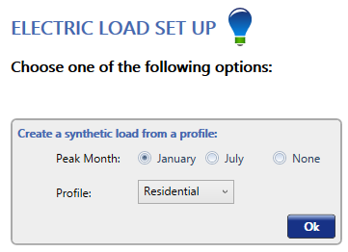

Figure 3: Load Set Up

The next step in building a model for the load of the remote community is to scale the data generated by HOME to account for the daily average. After approving the options selected in Figure 3 HOMER generates an hourly load model for a year and displays it as shown in Figure 4. The daily energy demand of the remote community is 10MWhrs. The load model in HOMER was scaled to ensure it observes the same behaviour. This can be verified in Figure 4 where the ‘Scaled Annual Average’ has been set to 10,000kWh per day.

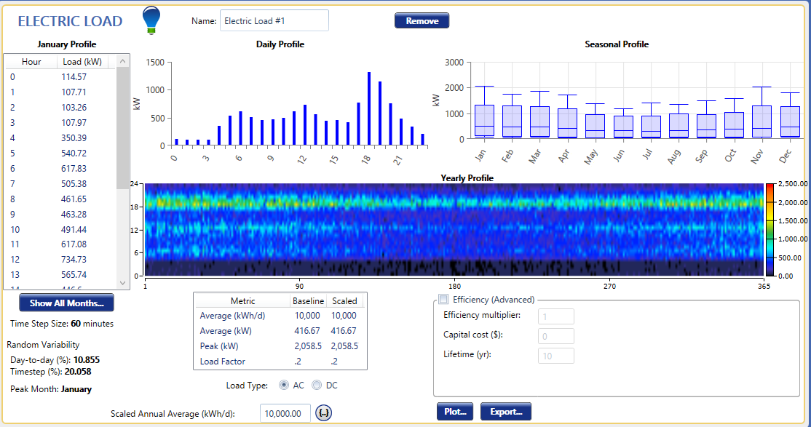

Figure 4: Load overview in HOMER

The load model generated by HOMER consists of 8760 data points to represent the load (in kWh) for each hour in the year. The load data was analysed as shown in Figure 5 to verify that 8760 data point had in fact been generated.

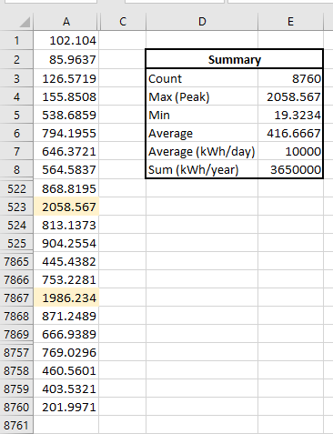

Figure 5: Load data analysis

In addition to the average daily load of 10MWhrs, the other consideration in modelling the community load is the peak demand. The load model must account for the fact that the community has a peak demand of 2MW. Figure 5 shows that the maximum load in the model generated by HOMER is just over 2MW. Some rows have been deliberately hidden in Figure 5 to indicate that there are 8760 data points and that to show two of the highest peaks in the load model.

Taking a closer look at the model used to simulate the load of the community, the average daily profile for each month was plotted in HOMER as depicted in Figure 6 below. The months of November, December and January are observed to have the highest peak loads.

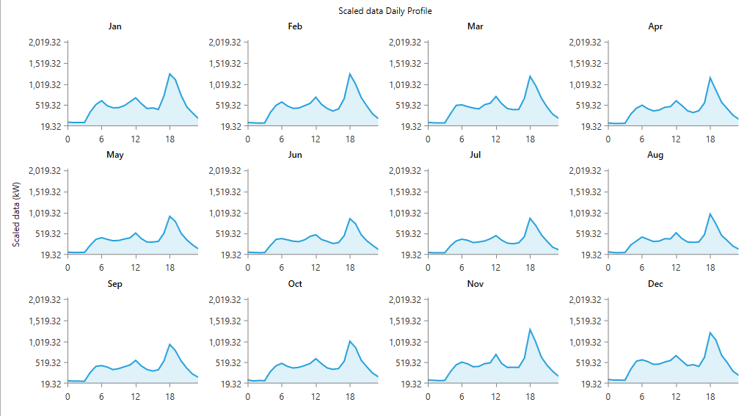

Figure 6: Average daily profile for each month

The demand over the course of a year is plotted in Figure 7. This plot can be manipulated in HOMER to provide insight into the demand profile at any particular period.

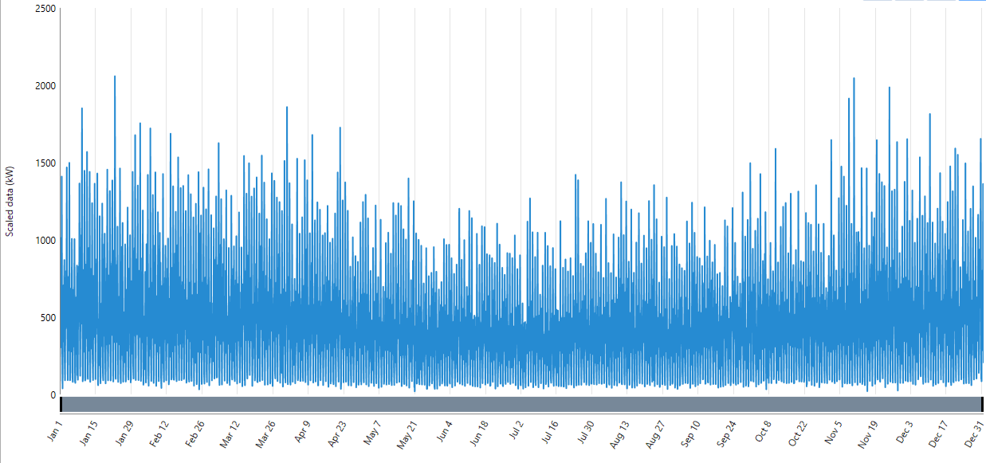

Figure 7: Load over a year

Figure 8 below shows the load profile over a specific day. This plot was obtained by modifying the timescale of the pot in Figure 7. This plot is presented here to show the maximum peak of 1.99MW that occurs at 6pm. This is consistent with the load of the remote community.

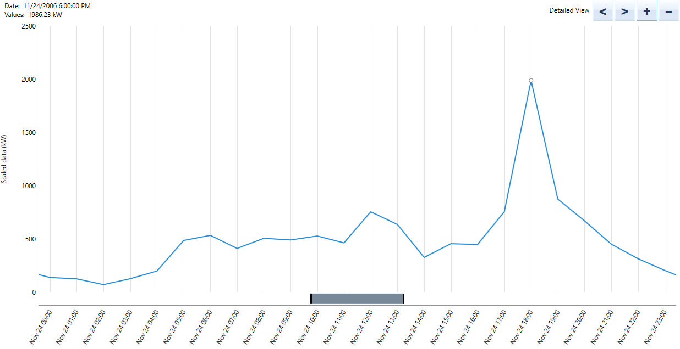

Figure 8: Load profile on 24 November

This section has discussed and verified the modelling of the load for the remote community. The model described here will be used in all subsequent simulations to ensure the performance of each scenario is assessed under the same load conditions.

## Base Case (Generator only)

To establish a baseline for comparison, the base case was simulated in which only the existing generator is used to meet the demand modelled in Section 6.1. The modelling parameters of the generator are summarised in Table 3 below.

|  |  |
| --- | --- |
| **Parameters: Existing Generator** | |
| Peak output | At least 2MW |
| Fuel (Diesel) Price | AU$ 1.30 per litre |
| Fuel consumption | 0.4 Litre per kWh |
| Cost per kWh | AU$ 0.40 per kWh |
| CO2 Emission | 2.7kg per litre of fuel |

Table 3: Modelling parameters for existing generator

HOMER has a variety of comments available to add to the simulation. To ensure that the simulation generates the appropriate statistics for meeting the load in Section 6.1, it was sized to have a maximum output of 2.2MW (see Figure 10). This ensures it can meet the peak load.

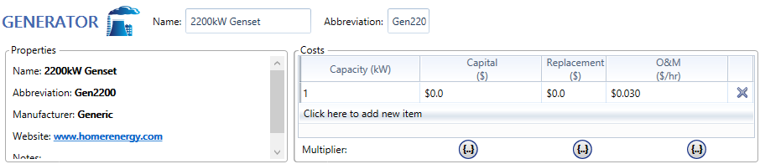

Figure 9: Generator specifications

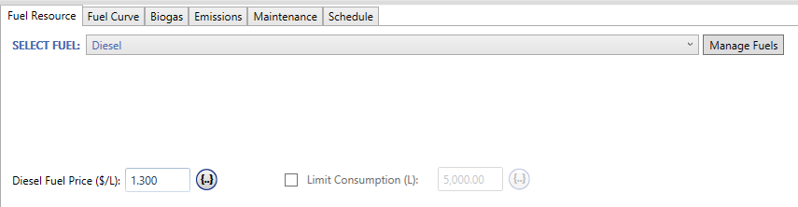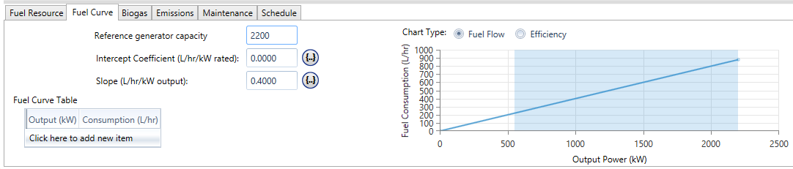

Figure 10: Generator fuel price and consumption rate

The price of fuel and fuel consumption were incorporated into the model as shown in Figure 10

Once these parameters were entered into the model, the simulation could be carried out. The results are presented by HOMER in the style shown in Figure 11. A more detailed report can be found in Appendix A1.



Figure 11: HOMER simulation output summary

From Figure 11 and the report provided in Appendix A1, it is observed that the generator consumes 1,460,000L of fuel while it runs continuously throughout the year (8760 hours). This equates to $1.9 million of diesel per year. Additionally, the operating and maintenance cost which was calculated to be $578,160 per year giving a total cost of $2.48m per year. The report produced by HOMER calculates the levelized cost of energy based on the capital cost and O&M costs over the whole project lifespan. From the report provided in Appendix A1 the cost of energy under the base case is found to be $0.40 per kWh. The total emissions produced by the system are shown in Table 4. These values were generated by the HOMER simulation, with the exception of the CO2 figure which was calculated based on 2.7 kg of CO2 per litre of fuel (see Table 4).

|  |  |  |
| --- | --- | --- |
| **Emission** | **Quantity** | **Unit** |
| Carbon Dioxide | 3,942,000.00 | kg/yr |
| Carbon Monoxide | 9,490.00 | kg/yr |
| Unburned Hydrocarbons | 1,051.20 | kg/yr |
| Particulate Matter | 715.40 | kg/yr |
| Sulfur Dioxide | 7,720.75 | kg/yr |
| Nitrogen Oxides | 84,680.01 | kg/yr |

Table 4: Base case emissions

The key metrics that will be used to compare the different systems proposed in this study are summarised in Table 5 below. These stem directly from the objectives of this study which are as follows:

* Minimise use of the existing diesel generator.
* Reduce overall cost per kWh of energy supplied
* Reduce the emission of carbon dioxide and other greenhouse gasses.

|  |  |
| --- | --- |
| **Base Case: Key comparison figures (per year)** | |
| Generator contribution | 3,650,000 kWh (100%) |
| Net present cost (NPC) | $32.0 million |
| Levelised cost per kWh | $0.40 per kWh |
| CO2 Emission | 3,942 tonnes |
| Initial capital outlay | $0 |

Table 5: Base Case - Key comparison metrics

Notice that in this case the initial capital outlay is $0 since the generator system is already installed. It is crucial that the levelised cost per kWh is used to compare different scenarios since the options presented will have a significant initial outlay but will have lower yearly running costs. Simply taking the cost per kWh over one given year will not give a fair comparison, instead the costs over the whole project life must be considered.

## Wind, Wave and Pumped Hydro

After establishing the base case, the next simulation that was carried out was the wind, wave and pumped-hydro solution. The simulation of this system was carried out for the same load and using the same generator model as described before. A model of a wind and wave power generating systems were added to the system along with a model of a pumped hydro-electric energy storage system. This system is outlined in Figure 12.

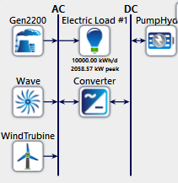

Figure 12: System Overview [Wind, Wave and Pumped-Hydro]

The first model that was added to the system was the wind power generating system consisting of between 0 and 10 wind turbines.

The replacement cost has been omitted as the wind turbines are expected to remain operational throughout the 25 year life of the project. This assumption is consistent with studies which investigated the lifecycle of wind turbines [39]. The capital cost of $400,000 per 250kW turbine was based on the range of $1.5m – $2m per MW provided in [40] which includes installation costs. The operating and maintenance cost used in the wind turbine model is $10,000 per year for each 250kW turbine. This is consistent with [41] which gives a range of $30 to $40 per kW for the annual maintenance of onshore wind turbines.

The search space was set so that wind power generation systems of between 0 and 10 turbines will be considered. HOMER will run simulations for each of these cases to assess the feasibility of each. The various combination will be discussed further when the results of the simulation are being analysed.

Figure 13: Wave Energy Flux - Monthly averages

The next system that was modelled is the Wave energy system. Since HOMER does not natively support wave power generation systems, an alternative modelling strategy had to be investigated. The procedure for modelling the wave energy in HOMER was based on research which suggested that a variation of the hydro model is used [42] [43] [44].

The monthly average wave energy flux for the open ocean closest to the chosen location (31.991 $°$ S, 115.725 $°$ E) was retrieved from [45] and is displayed graphically in Figure 13.

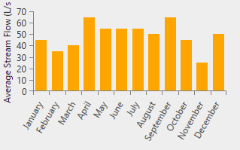

Figure 14: Stream flow data to mimic wave energy [43]

To adapt the hydro model in HOMER to model wave energy, the method in [43] was used to determine the appropriate stream flow rate data which was entered into HOMER. The stream flow rate was entered into HOMER which allowed the hydro model to mimic a wave energy power generation system is shown in Figure 14.

Now that the environment has been set up for the hydro model to act as a wave energy model it can be added to the system. Figure 15 shows the parameters for the wave energy model. As with the wind generation system, multiple sizes will be simulated for wave energy system model. Next to the capital cost in Figure 15, the 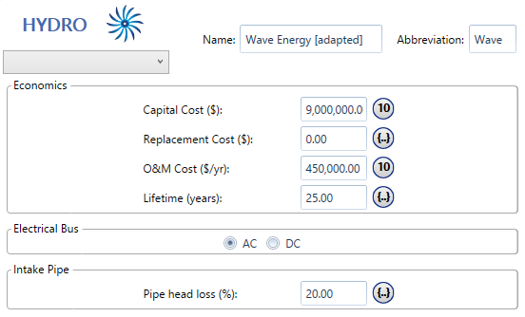 indicates that 10 different sizes will be simulated hence 10 different capital cost figures as each size is linked to a different capital cost. The sizes that were simulated range from 0kW to 2.25kW. The capital costs associated with the wave energy system is based on $4000 per kW. The annual operating and maintenance cost also shown in Figure 15 has been calculated as 5% of the initial capital. These figures are consistent with other feasibility studies and real world case studies [46] [47].



Figure 15: Wave energy system specifications

The final addition to the system is the pumped hydro model. In HOMER the pumped hydro model generates direct current (DC) power, hence an inverter system is required. First the pumped hydro model was configured as shown in Figure 16.

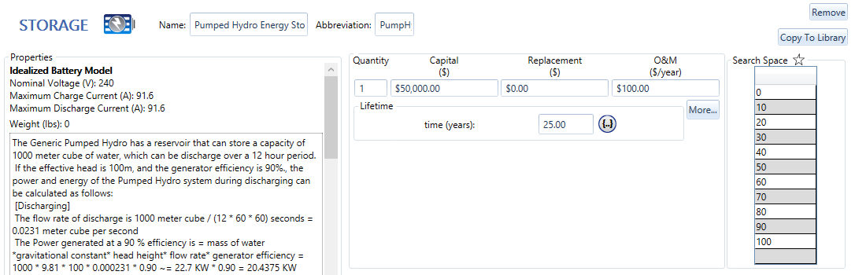

Figure 16: Pumped Hydro model parameters

The model presented by HOMER as a pumped Hydro system is based on a battery storage model and only a limited selection of parameters was available to the user. The pumped hydro model was configured to have a cost of approximately $2,200 per rated kW and an annual operating and maintenance cost of $4.50 per rated kW of the system. These figures were drawn from the range of real world systems analysed in [48]. Since the only available pumped hydro model in HOMER is quite small, the search space was varied in large increments. One unit of the HOMER pumped hydro system is capable of storing 245kWh with a rated output in the order of 22kW. Clearly a much larger system is required, hence the smallest size that will be simulated is 10 units or 220kW in size.

Along with the pumped hydro model, a system converter is required since the pumped hydro model is based on a DC system. An inverter system of 2200kW was added to the simulation since the peak load is expected to be 2MW. The inverter was configured to have an efficiency of 90% and a capital cost of $140 per kW [49].

After all these components were added, the system was ready to be simulated. HOMER ran multiple simulations for each combination of the three renewable energy sources of varying sizes and produced a list of options. These options were sorted by the NPC as the lowest net present cost would give the lowest cost per kWh over the life of the project. The second consideration in deciding on an option was the ‘renewable factor’ which is the percentage of the total power that was generated from renewable sources. This value gives a quick indication of how much the generator contributed in each scenario. This simplifies the process of evaluating the options based on the use of the existing generator which is directly related to the emissions in each case. Using these criteria for selection, the most suitable option had been selected in Figure 17 which incorporate all three renewable energy systems.

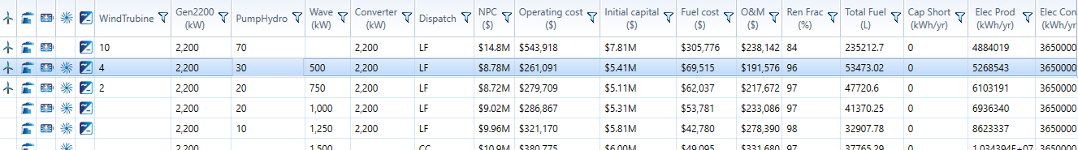

Figure 17: HOMER optimisation - Wind, Wave and Pumped Hydro

In addition to the figures shown here, a more detailed report can be found in Appendix A2. One of the key factors to be considered is the contribution of the existing generator. Figure 18 below shows breakdown of the generation in each month. The most dominant source of power generation throughout the year is the wave energy system. The wind turbines contribute between 25% and 50% in each month. In most months, the contribution of the generator is negligible, however in February and November the generator makes a noticeable contribution.

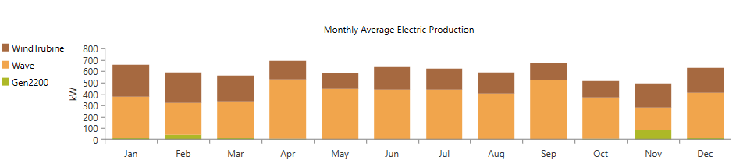

Figure 18: Monthly averages of power generation

From the simulation report generated by HOMER (Appendix A2), the energy production is shared between the sources as shown in Table 6.

|  |  |
| --- | --- |
| **Energy production** | |
| 2200kW Genset | 2.54 % |
| Wind | 32.62 % |
| Wave Energy | 64.85 % |

Table 6: Breakdown of energy production

Figure 19 on the page over provides more insight into the dynamic behaviour of the three generation systems and the energy storage system.

From Figure 19 it is observed that the generator is only required at periods of peak demand. The wave energy on the other hand acts somewhat like a base load at around 500kW. The wind turbine contribution varies widely across the simulation with the hydro storage compensating every time there is a slump in wind energy output.

Demand

Wind

Wave

Pumped Hydro

Generator

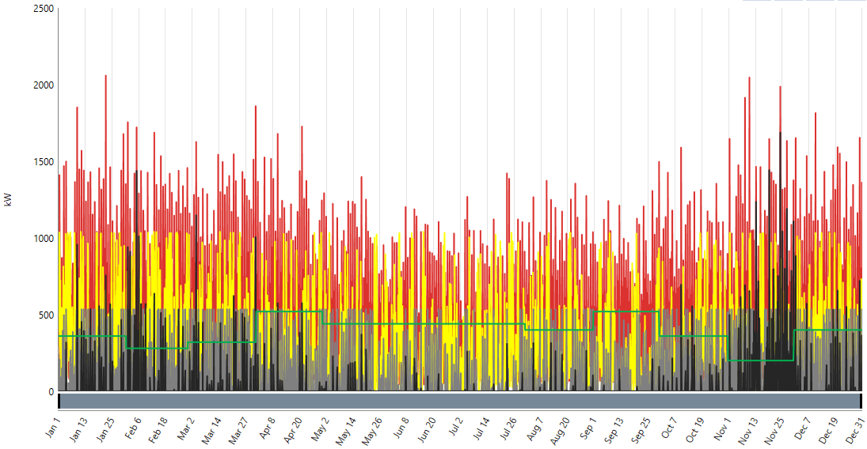

Figure 19: Time series power generation and demand

The generator contribution amounts to 133,683 kWh per year which equates to 53,473L of fuel. Based on 2.7 kg of CO2 per litre of fuel the emission of carbon dioxide is calculated to be: 144,377 kg/year. The emissions under the proposed design are summarised in Table 7.

|  |  |
| --- | --- |
| **Emission** | **Quantity** |
| Carbon Dioxide (kg/yr) | 144,377 |
| Carbon Monoxide (kg/yr) | 347.57 |
| Unburned Hydrocarbons (kg/yr) | 38.50 |
| Particulate Matter (kg/yr) | 26.20 |
| Sulfur Dioxide (kg/yr) | 282.78 |
| Nitrogen Oxides (kg/yr) | 3,101.43 |

Table 7: Wind, Wave and Pumped Hydro - Emissions

To aid comparison between the designs proposed in this study, the key metrics used for comparison are summarised in Table 8 below.

|  |  |
| --- | --- |
| **Wind Wave and Pumped Hydro: Key comparison figures** | |
| Generator contribution (kWh per year) | 133,683 (3%) |
| Excess energy (kWh per year) | 1,384,889 |
| Net present cost (NPC) | $8.78 million |
| Levelised cost per kWh | $0.186 per kWh |
| CO2 Emission (tonnes per year) | 0.144 |
| Initial capital outlay | $5.408 million |

Table 8: Wind, Wave and Pumped Hydro - Key comparison metrics

Clearly the three key objectives have been well targeted by the proposed system. Comparing the lifetime costs of the proposed system against the base case presents a 97% reduction in the use of the generator and hence the CO2 emissions. The cost per kWh over the life of the project has been reduced by 80% since the large initial outlay is compensated by the lower running and maintenance costs under the proposed system.

## Photovoltaic, Wind and Battery

A photovoltaic, wind and battery system was also created and simulated which will be compared to the previous wind, wave and pumped hydro system in Section 5.5. This system contained the same generator model as described in section 5.2 along with photovoltaic and wind power generation systems and a battery storage system. This system is outlined in Figure 20.

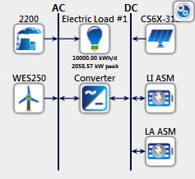

Figure 20: System Overview [PV, Wind, Battery]

The PV model that was added to the system was the photovoltaic system which was sized between 0 to 5 MW. Next the wind power system was modelled to containing between 0 to 20 turbines.

Replacement costs of the PV system was set at zero over the 25 years as it is expected that PV system would not need to be replaced. The capital cost of the PV system was said to be $4000 per 5kW [ref email]. Operational and maintenance costs used in the wind turbine model is $10,000 per 1 kWh for solar and $10,000 per turbine.

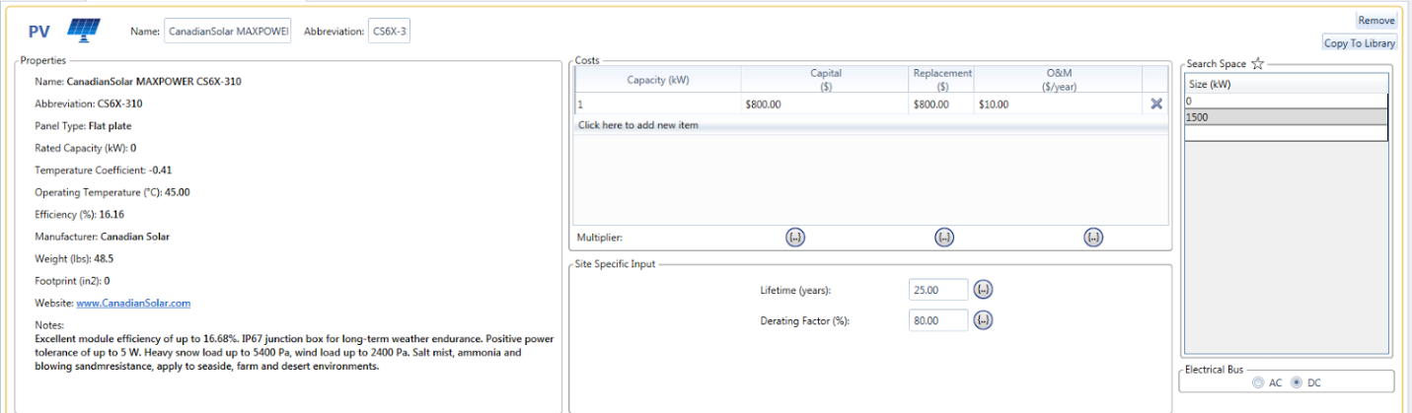

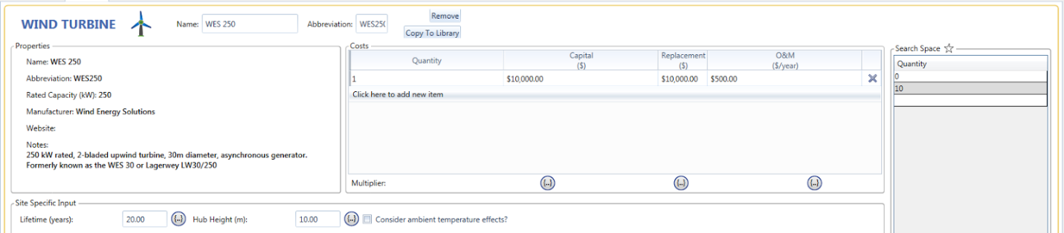

Figure 21: PV model parameters

The storage system of Lithium Ion and Lead Acid battery systems where given to HOMER for optimization. Lithium Ion was $600 per battery capital cost (1 kWh battery rated 3.7V and 276 Ah) and $600 per replacement with $10 operational costs. The Lead Acid system also had a $300 per battery capital cost (1 kWh battery rated 2V and 513 Ah) and $300 per replacement with $10 operational costs.

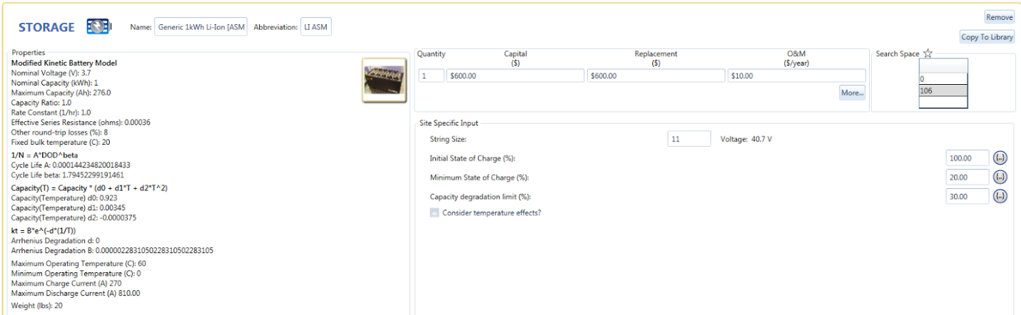

Figure 22: Battery model parameters

The converter used in this system is the same as that described in previous wind, wave and pumped hydro system, 2200kW with 90% efficiency $140 capital and replacement costs.

These options were sorted by the NPC as the lowest net present cost would give the lowest cost per kWh over the life of the project. The second consideration in deciding on an option was the ‘renewable factor’ which is the percentage of the total power that was generated from renewable sources. This value gives a quick indication of how much the generator contributed in each scenario. This simplifies the process of evaluating the options based on the use of the existing generator which is directly related to the emissions in each case.

The final system consisted of 1500 kW PV system, 10 250 kW wind turbines, 1166 Lithium ion batteries and 2200 kW converter. In this system the generator contribution amounts to 14%, see Table 9, of the energy production in the system and remains constant throughout the year, as in Figure 23 and Figure 24.

|  |  |
| --- | --- |
| **Energy production** | |
| 2200kW Genset | 14 % |
| Wind | 55 % |
| Photovoltaic | 31 % |

*Table 9: Breakdown of energy production*

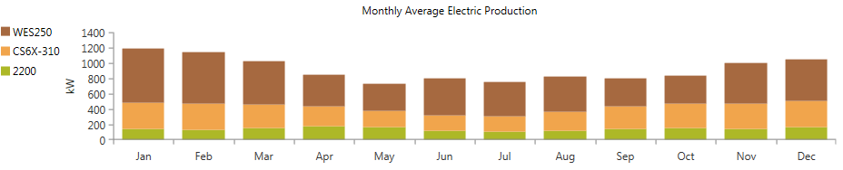  
Figure 23: Monthly averages of power generation

The most dominant source of power generation throughout the year is the wind power system. The wind turbines contribute between 50% and 75% in each month. PV power generation is consistently between 100 kW and 200 kW production per month. The wind turbine contribution varies widely across the simulation with the battery storage compensating every time there is a slump in wind energy output.

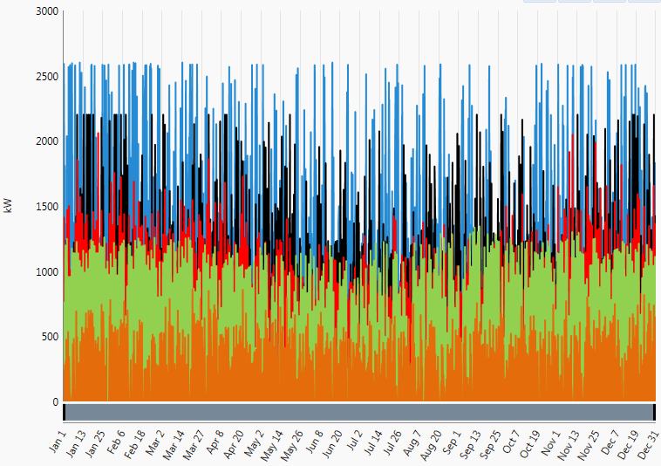  
Figure 24: Time series power generation and demand PV, Wind and Battery System.

|  |  |
| --- | --- |
| **Emission** | **Quantity** |
| Carbon Dioxide (kg/yr) | 1,118,866 |
| Carbon Monoxide (kg/yr) | 2,762 |
| Unburned Hydrocarbons (kg/yr) | 306 |
| Particulate Matter (kg/yr) | 208 |
| Sulfur Dioxide (kg/yr) | 2,267 |
| Nitrogen Oxides (kg/yr) | 24,643 |

Table 10: PV, Wind and Battery Emissions summary

The generator contribution amounts to 1,240,674 kWh per year which equates to 424,886 L of fuel a year. Based on 2.7 kg of CO2 per litre of fuel the emission of carbon dioxide is calculated to be: 1,147,192 kg/year. The three key objectives have been well targeted by the proposed system as it reduces generator consumption by 70% lowered cost of electricity by 32% and have a low capital cost of under $4 million, shown in Table 11. The reduced use of the generator also leads to a reduced carbon emission of 77% from the base generator only case.

|  |  |
| --- | --- |
| ***PV, Wind and Battery: Key comparison figures*** | |
| *Generator contribution (kWh per year)* | 1,062,216 |
| *Net present cost (NPC)* | $14,811,852 |
| *Total kWh delivered (per year)* | 7,843,895 |
| *Cost per kWh (over 25 years)* | $0.314 |
| *CO2 Emission (tonnes per year)* | 1,118 |
| *Initial capital outlay* | $3.8 million |
| *Excess Electricity Generated (kWh per year)* | 3,990,071 |

Table 11: Key comparison metrics PV, Wind and battery system.

## Summary and Comparison

Both systems that were developed in this section have achieved the outlined design requirements. This section will outline the main advantages and disadvantages of the first case (wind, wave and hydro) and the second case (PV, wind and batteries) systems. The initial cost of the first case is $8.8 million which is more than half of the $3.8 million of the second system. Although, the first system does minimise the generator use and cost of electricity significantly more in theory than the second system.

# Technical and economic feasibility

## Wind, Wave and Pumped Hydro

## Photovoltaic, Wind and Battery

One of the renewable energy systems proposed for the remote community was PV, wind and battery storage. In section X.X this system was modelled and the optimal solution consisted of a 1.5 MW PV system, 10 WES 250 wind turbines, 1166 lithium-ion batteries and the original 2.2 MW generator which the community had been using to generate their required energy. Although mathematical simulations using HOMER have proven that this system is an optimal solution technical and economic feasibility must also be considered.

The specific PV panels used for the simulation where CanadianSolar CS6X-310 panels. Each panel had a rating of 310 W and an area of 1.92 m2 [1]. Given the system proposed was 1.5 MW there would need to be approximately 4,839 panels with a total area of 9,285 m2. This calculation assumed each panel would lay flat on the ground, and therefore would increase if the panels were to be tilted, to avoid any shading caused by neighbouring panels. The remote location of this community would suggest that a PV system of this size would be feasible. This system could also be placed close to the community to reduce the need of long transmission lines.

The 10 WES 250 wind turbines have total rated power output of 2.5 MW. Unlike PV, wind turbines must be placed both a certain distance from each other and a certain distance away from the community. When wind turbines are operational they can produce a large amount of noise which can be off putting to residents of the remote community. With this in mind the wind ‘farm’ would need to be located at least 500 m away from the community to minimize the effect of noise. Spacing between turbines would be 4Dx8D this spacing would eliminate wake effects produced by the turbines. With a rotor diameter of 30 m [50] this would give a total area of 288,000 m2. Although the area of the wind farm is large a remote community would have enough surrounding space to implement the farm. Other than distance required to minimize noise the wind farm can be placed close to the community and therefore the need for long transmission lines will be eliminated. It could also be possible to place both the wind ‘farm’ and the PV array on the same area adjusting the shape of the PV array to avoid any shading caused by the turbines. However, due the nature of community being ‘remote’ the two array can be placed on different locations near the community.

One possible problem for the system would be the housing of 1,166 Li-Ion batteries. The location of the storage system would need to be in close proximity to both the PV and wind systems to reduce the need for transmission lines. Given the large quantity of batteries needed to stabilize the system, proper infrastructure would need to be built in order to protect the batteries and the community. Large scale storage facilities have been implemented around the world and therefore housing the large amount of batteries required for this system would be feasible.

|  |  |  |  |
| --- | --- | --- | --- |
|  | **Quantity** | **Area** | **Capital Cost** |
| **PV** | 4,839 | 9,285 | $1,200,00 |
| **Wind** | 10 | 288,000 | $100,000 |
| **Batteries** | 1,166 | - | $699,600 |

Table 12: Cost and area for the PV, Wind and battery system.

## Summary and Comparison

# Environmental constraints and future prospects

Renewable energy is currently constrained in many different respects. However, the technology has already made great leaps forward, and there’s no sign of this progress slowing down. The future looks very positive for the technology on the whole. This section of the report will investigate the various constraints currently hindering renewable energy, and will also ponder what its future prospects are is – particularly in Australia.

*Political*

Renewable energy is to a large extent a captive of politics. This is particularly evident in Australia. The prime minister in office has a lot of sway on whether renewables flourish or falter. Strong evidence of this is the fact that Tony Abbott repeatedly tried to do away with the pro-renewable policies of his predecessor. Julia Gillard was a strong proponent for renewable energy, and founded state-owned research organisations to promote the development of the technology. When Abbott then attempted to dissolve such organisations, investment in renewables faltered.

It has been made evident that the attitude of the minister in charge has a clear impact renewable energy. Minsters in the past who have been in favour of implementing pro-renewable rebates have succeeded in making Australia the country with the most household solar panels in proportion to population in the world. However, what is quite problematic is that the attitude of politicians towards renewables in Australia is quite turbulent. If Australia is to be successful in reaching the renewable energy targets it sets, it needs to have a more consistent outlook.

*Economic*

Renewable energy can benefit individual households by lowering the amount of utility power they consume. When implemented on a large scale, the country’s economy can benefit because it means that the amount of resources burned to produce electricity is lowered. These resources can instead be exported to other countries for profit. A great example of this concept being put into practise is found in Norway. Not only does the country run essentially 100% renewable energy (predominantly from hydroelectricity), but it is also a massive exporter of oil and gas. Instead of using such resources for electricity production, they sell it. This strategy has certainly been a contributing factor to the country having one of the strongest economies in the world.

*Social*

Renewable energy sources have received amazingly varied responses around the world. While the majority of society is in favour of the technology, it sometimes has negative effects on residents. The single source of renewable energy which has received the most criticism from society is wind turbines. The turbines are known to make a large amount of noise which can be a nuisance to people living nearby. It is very critical that a lot of consideration be put into site selection, such that the impact on society is minimised.

In the case of wind turbines, perhaps the answer is to place them in the oceans as opposed to the countryside. After all, there are much fewer impediments blocking the wind in the ocean, so it might be preferred in a technological sense in addition to a societal sense. However, there are certain instances where not everyone can be pleased. For example, some people find solar panels on rooftops to be aesthetically displeasing.

*Technological*

The efficiency of renewable energy sources has steadily increased since its inception. Silicon solar cells are nearing their theoretical maximum efficiency. However, by combining different materials together and making use of substance doping, some cells have reached efficiencies over 40%. Because renewable energy is currently receiving a lot of support around the world, more money is being put into the research and development of the technology. As a result, the technology will continue to improve.

*Legal*

There are various laws that currently constrain renewable energy sources. One such form of regulation is the requirement that the bus voltages of the electrical grid must operate within a certain range. Solar panels, as well as other forms of distributed generation have become notorious for causing the bus voltage to exit the acceptable range. Overvoltage is one common occurrence. This problem is strongly linked to the variability of many renewable sources. It just so happens that the sun shines at its brightest when the load demand is at its lowest. This often leads to reverse power flow because more power is produced than is being consumed.

*Environmental*

While the cause of renewable energy being prominent around the world is that it benefits the environment, it has some negative connotations attributed to it which must not be overlooked. Wave power can disrupt the natural flow of water. Hydroelectricity is notoriously destructive to the local river wildlife. Wind turbines are deadly to birds and other forms of wildlife. It is extremely important that full consideration is given to such factors before a system is installed.

# Personal Reflection

| **Student:** | **Personal Reflection:** |
| --- | --- |
| Steven Bardzovski (21121998) | The project required the proposal of two different renewable energy systems that could be implemented in a remote community. Therefore, it was decided that the team be split into two groups of 3, with each group tackling one of the renewable energy systems. Anthony, Miles and Tom worked on the wind, wave and pumped hydro renewable system while Elzenic, Francois and I worked on the PV, wind and battery renewable system. Splitting the team into two groups allowed us to complete the two systems in parallel which meant that someone always had a job to do and the project was being completed in the most efficient manner.  Before splitting into the two groups every team chose either a renewable energy technology (PV, wind, tidal, and wave) or storage (battery, pumped hydro, and compressed air) and wrote a literature review on their topic. The literature reviews were then compiled into one section by Francois, who also completed the business case, environmental constraints and future prospects. Roles were also delegated within the small groups. In the PV, wind and battery group Elzenic and I were working through the simulations on HOMER trying to find the optimal number of wind turbines, solar panels and batteries needed for the remote community. Once we were happy with our configuration Elzenic wrote the modeling section for our renewable system while I wrote the technical and economic feasibility of the system. Similar roles were assigned in the other group with Tom leading the HOMER simulations of the wind, wave and pumped hydro system. Along with writing the modeling and simulations section for the second system Tom also completed a gantt chart. Miles and Anthony contributed to the optimisation of the wind, wave and pumped hydro system and the technical and economic feasibility write up.  As a team we had strengths and weaknesses that benefited and caused challenges in the completion of the project. One of the strengths of the team was that we were very organised, within the first two meetings we had already completed the literature review, decided on the two renewable systems and split into the two groups of 3 for each renewable system. A weakness that we had as a team was that we did not have high priority for this project. Many of the team members had thesis and design projects due around the same time of semester and therefore focused more on those projects, because of this our time management changed and we fell behind our time frames.  Overall I enjoyed this project, I believe everyone, including myself, contributed evenly and fairly to its completion. The team consisted of hard working and motivated individuals, who gave everything they had to the completion of the project. If we were to complete the project again I think we would have to reassess our time frames and make sure we stick to completing each component of the project in the specified time, however, changing time frames are sometimes an unavoidable event that occurs in every project. |
| Elzenic Basson (21111387) | *Initial Decisions*  In the initial meeting, it was decided as a team that we should create the final report in a neat manner so it can be well presented. This thus called for a main writer which Francois volunteered for and a main editor which was decided to be Steven. From there we formulated a plan for the project as to how the tasks would be completed and Tom created a gantt chart for us to guide us through the project.  *Literature Review work*  The work for this project was split between the group members to suit their skills, strengths and weaknesses. I completed research and a literature review on battery storage and compressed air storage systems as these I had connections which aided in my research. Francois had a passion for solar then the remainder was devised with Anthony for wave, Tom for pumped hydro, Miles with tidal and Steven with wind.  *Deciding on two plausible cases and splitting team*  After the literature review was completed by each team member we decided on two systems PV, Wind and Batteries and Wind, Wave and pumped hydro. The team was then split into two sub groups based on their skills and also which material they covered in the literature review section. Due to our strong mathematical background, we decided as a team that Steven and I complete the modelling and simulation of the wind and pv system and Tom for the wind, wave and pumped hydro. I explored the options available for the team to run simulations on with matlab/ simulink being the first port of call and then exploring HOMER to see if that would be more beneficial and easy to pickup. The result was that the team agreed, with evidence provided in form of screenshots and explanations, that HOMER would be the simulation software to use going forward. Tom, Steven and I made sure to keep contact as we progressed through the simulations to ensure we were using the same base load, generator and to compare results. Anthony and Miles worked on the feasibility for the wind, wave and hydro system with Steven doing same for PV, wind and battery system.  *Final report contributions*  I wrote up the modelling and simulation section for PV, Wind and battery system and modelling comparison section between two design systems of the final report. Care was taken to work closely with Tom to ensure the sections matched and presented similar points in the report.  *Improvements*  There are a few improvements we could achieve as a group, I should have ensured more transparent communication between Tom, Steven and I as there were a couple of incidents of miscommunication. The group was good at keeping each other motivated, on track and with an even workload. Good communication between team members as to who is being over loaded by other units and who was not was consistently identified and adjusted throughout the project. Though communication was lacking in the group when it came to consistent meeting times and unfortunately it was rare to have all the team members present for the meetings. The overall process worked well and the team members all contributed, the main improvement would be more consistent interaction between the sub groups during the modelling task. |
| Miles Cattach (21124567) | This project has allowed us students to grow from an initial group into a well formed team. As a team we performed well, delegating tasks according to individual members strengths whilst also encompassing the entirety of the project scope. As a group we broke the project into sub section including the literature review, the business case, the modelling, the feasibility and the environmental impacts. Each student was assigned a particular generation or storage method in which in individual conducted the literature review. This then allowed the team of six to be later separated into two smaller groups of three, in which each sub group modelled and conducted the feasibility study for each design. This allowed for more frequent communication within each sub group of three while still producing the overall deliverable. Whole group meetings were still conducted on a regular basis which allowed each sub group to openly discuss their methods, strategies and shortcomings with the entire group. This method of group subdivision allowed more frequent conversation with the necessary parties and offered more diverse feedback on more general issues. The biggest weakness of this method was due to the fact that a common meeting time for six students did not occur once during the project within general working hours. This is understandable as the six students were all in different stages of their studies and as such it was hard time find a suitable time. For future improvements I would recommend perhaps meeting outside of working hours in order to allow all student to attend full group meetings, however I understand that this is not welcomed by some.  My Individual role in this project was mostly researched based as understanding the technologies, their impacts and dependencies played a vital part in modelling and analysing the proposed systems. Regarding the report, I undertook the research into the tidal generation schemes for the literature review. However, this method of generation was deemed unsuitable for use and as such more I needed to further develop my individual understandings of the systems which were modelled. In our sub group of three students (Tom, Anthony and Myself) we modelled the wind, wave and pumped hydro system which entailed more research into the systems. This research provided useful information for the modelling of the system which was primarily undertaken by Tom in our sub group of three. Anthony and myself researched in more depth the feasibility of the proposed system and jointly wrote the feasibility section regarding the wind, wave and pumped hydro system. |
| Thomas Conradie (21127771) | I have thoroughly enjoyed being part of this team. It is a joy to work with like-minded students who share the same passion for excellence and are eager to work diligently to produce work of high standards. The team, collectively, shared an urgency to complete the task efficiently and to a high standard. A great contributing factor to our success was the fact that each member of the team had prominent strengths that could be applied in ways that complemented the strengths of other members.  Mutual encouragement, communication and accountability are key factors to success in any team. I facilitated these factors throughout the project, by ensuring that everyone feels included in each team meeting and by being actively involved in online group discussions. By creating and maintaining a project timeline Gantt chart, I helped the team manage the challenge of task scheduling, task assignment and task inter-dependencies. Upon creating the Gannt chart I defined various tasks and roles. These were assigned to members of the team according to their personal strengths and interests. Initially each team member conducted a literature review into the area they are most interested in. Once the two renewable energy options were decided by the team, the role assignment involved tasking half the team to one proposed option and the other half to another option.  The team was completely unfamiliar with HOMER before working on this project. I initially proposed that we use MatLab Simulink since I am experienced in it. However, once we saw that HOMER provides a streamlined workflow for comparing not just the power flow of a particular option but also the economics, the team and I promptly decided to use HOMER. Elzenic and I took the lead roles in working with HOMER. To ensure we were consistent in the approaches we used, I performed the initial simulations for the load, base case and wind/wave/pumped-hydro systems. After documenting the procedures I followed, I assisted Elzenic to ensure a consistent approach is followed. This was a demonstration of my competency in leadership as I set an example and made myself available to offer advice and guidance.  A challenge often faced when working in a team is document collaboration. It can be difficult to manage document drafts without creating conflicting copies between members. In this assignment, this task was managed well by having agreed file sharing and modification procedures, nevertheless, some aspects that need improvement were identified. I aided the team by setting up the appropriate file structures in the team’s online file sharing repository and ensuring everyone understood the version control procedures. I created a template and initial draft of the final report along with headings, style sets and task guidelines. The purpose of doing this was to ensure each team member knows where their part fits into the final report and to aid the final quality control of the document by ensuring the formatting and layout is consistent throughout.  I personally find renewed motivation to study a concept once I understand the physical application. This project has given me the opportunity to investigate, extend and apply the concepts discussed in lectures. It has also presented me with a more realistic problem than presented in lectures and tutorials where problems are often artificial and specifically designed to be solved in a certain way.  The project demonstrated that there is often more than one way to solve problems in the real world. Solutions are often not necessarily right or wrong, but some solutions are simply better than others. The wealth of options explored in this assignment before reaching the final proposed options was a great example of the trade-offs that engineers face.  I wish to thank my team for their commitment even under very stressful circumstances. Most members in the team are in their final year and had to manage multiple group projects and thesis projects in conjunction with this project. |
| Anthony McKinley (20758849) |  |
| Francois Pieters (21200276) | *Group roles*  In our first meeting (22/09/16), we split the research which would be used to compile the literature review among ourselves. It was great that all the members of the team were willing to start on the project so long before it was due. In this way, we succeeded to cope with the time pressure quite well. Once the literature review was complete, we decided that a useful strategy would be to split the group into 2 smaller components – with each component working on a different design. Hence Thomas, Miles and Anthony worked on the Wind/Wave/Pumped Hydro design while Elzenic, Steven and myself worked on the Wind/Solar/Battery design. We made sure to allocate members into these 2 components based on which technologies they were experienced with or passionate about. We also decided that it would be good to allocate general roles within the group. Thomas is quite passionate about software simulations, thus it was decided that he should be the main programmer. Elzenic and Steven took a lot of responsibility with the simulations as well. Meanwhile, Anthony and Miles volunteered themselves to perform the feasibility and technical study on the Wind/Wave/Hydro design.  *My roles*  Some engineering students don’t always feel comfortable writing a lot in reports. I tend to enjoy this responsibility however, and thus volunteered myself to do a great deal of the writing of the report. I first completed the literature review of solar energy. Then I took on the responsibility of compiling everyone’s literature review sections into a single piece. This involved quite a lot of time getting the referencing consistent since everyone used a different form of referencing. Unfortunately I had to manually redo all the referencing in the literature review in order to achieve consistency. In keeping with my love of writing, I volunteered to write the introduction, business case, and constraints and future prospects.  *Strengths and weaknesses of the team*  The team was very diligent, which meant that we were able to complete the project well within the allocated time. We were also very clever to split the responsibilities of the project amongst ourselves in a sensible way. Not only did we split the responsibilities according to what each member was good at, but we also considered the passions and interests of group members. In terms of weaknesses, we certainly could have communicated much more closely. Unfortunately all members of the group had numerous other responsibilities to tend to, which certainly hindered the willingness or ability to communicate effectively.  *Possible improvements in the overall process*  I would say the biggest improvement we could have made was to find a time which suited all members and then meet during that time on a weekly basis. It was quite tough to find a time that suited everyone though, which certainly had detrimental repercussions. Another area we could improve is to use consistent style when writing the separate sections of the report. The team should have agreed to a single form of referencing from the very beginning. Google Docs or Overleaf could have also been used to promote a consistent style. What we ended up doing instead was writing separate sections and then combining them together afterwards – which created a lot of unnecessary editing. |

# References

|  |  |
| --- | --- |
| [1] | H. King, Nuclear Energy and the Fossil Fuel, New York: American Petroleum Institute, 1956. |
| [2] | REN21, “Renewables 2015 Global Status Report,” UNEP Collaborating Centre, Frankfurt, 2015. |
| [3] | N. Apergis and J. Payne, “Renewable energy consumption and economic growth: Evidence from a panel of OECD countries,” *Energy Policy,* vol. 38, no. 1, pp. 656-660, 2010. |
| [4] | Department of the Environment and Energy, “environment.com.au,” Australian Government, n.d.. [Online]. Available: https://www.environment.gov.au/climate-change/renewable-energy-target-scheme. [Accessed 02 11 2016]. |
| [5] | W. Hoffmann, “PV solar electricity industry: Market growth and perspective,” *Solar Energy Materials and Solar Cells,* vol. 90, no. 18, pp. 3,285-3,311, 2006. |
| [6] | A. Goetzberger, J. Luther and G. Willeke, “Solar cells: past, present, future,” *Solar Energy Materials and Solar Cells,* vol. 74, no. 1-4, pp. 1-11, 2002. |
| [7] | C. Hill, M. C. Such and D. Chen, “Battery Energy Storage for Enabling Integration of Distributed Solar Power Generation,” *IEEE Transactions on Smart Grid,* vol. 3, no. 2, pp. 850-857, 2012. |
| [8] | A. Goodrich, T. James and M. Woodhouse, “Residential, Commercial, and Utility-Scale Photovoltaic (PV) System Prices in the United States: Current Drivers and Cost-Reduction Opportunities,” National Renewable Energy Laboratory, Colorado, 2012. |
| [9] | R. Naam, “Smaller, Cheaper, Faster: Does Moore's Law Apply to Solar Cells?,” *Scientific American,* vol. 16, 2011. |
| [10] | B. Igliński, A. Iglińska, G. Koziński, M. Skrzatek and R. Buczkowski, “Wind energy in Poland – History, current state, surveys, Renewable Energy Sources Act, SWOT analysis,” *Renewable and Sustainable Energy Reviews,* vol. 64, pp. 19-33, 2016. |
| [11] | Y. Kumara, J. Ringenberga and S. S. Depurua, “Wind energy: Trends and enabling technologies,” *Renewable and Sustainable Energy Reviews,* vol. 53, pp. 209-224, 2016. |
| [12] | International Energy Agency, “iea.org,” 2014. [Online]. Available: http://www.iea.org/publications/freepublications/. [Accessed 10 10 2016]. |
| [13] | R. Charlier and C. Finkl, Ocean Energy: Tide and Tidal Power, Heidelberg: Springer, 2009. |
| [14] | R. A. Dunlap, Sustainable Energy, Stamford: USA: Cengage Learning, 2015. |
| [15] | R. F. Kempener, “Tidal Energy - Technology Brief,” IRENA, 2014. |
| [16] | Marine Current Turbines, “marineturbines.com,” 2014. [Online]. Available: http://www.marineturbines.com/3/news/article/56/seagen_tidal_turbine_gets_all_clear_from_environmental___scientific_studies. [Accessed 10 10 2016]. |
| [17] | R. Kempener, “Wave Energy Technology Brief,” *Abu Dhabi: International Renewable Energy Agency,* 2016. |
| [18] | EMEC Orkney, “emec.org.uk,” 2016. [Online]. Available: http://www.emec.org.uk/marine-energy/wave-devices/. [Accessed 14 10 2016]. |
| [19] | ABC News, “abc.net.au,” 2015. [Online]. Available: http://www.abc.net.au/news/2015-02-18/wa-wave-energy-project-turned-on-to-power-naval-base/6141254. [Accessed 14 10 2016]. |
| [20] | MI News Network, “marineinsight.com,” 2015. [Online]. Available: http://www.marineinsight.com/offshore/the-agucadoura-wave-farm-the-worlds-first-wave-farm/. [Accessed 15 10 2016]. |
| [21] | D. O. Akinyele and R. K. Rayudu, “Review of energy storage technologies for sustainable power networks,” *Sustainable Energy Technologies and Assessments,* vol. 8, pp. 74-91, 2014. |
| [22] | S. Chan, Lithium Ferro Phosphate (LFP) Batteries, Sydney, 2016. |
| [23] | Schlumberger SBC Energy Institute, Leading the Energy Transition, Electricity Storage, 2013. |
| [24] | J. M. Grothoff, “Battery Storage for Renewables: Market Status and Technology Outlook,” IRENA, Dusseldorf, 2015. |
| [25] | D. O'Brien, “Investigation of Lithium Iron Phosphate Battery Technology and Performance in WA Conditions,” The University of Western Australia, Perth, 2015. |
| [26] | AECOM Australia Pty Ltd, Energy Storage Study Funding and Knowledge Sharing Priorities, 2013. |
| [27] | The Earth Institute, Columbia University, “How Better Battery Storage Will Expedite Renewable Energy,” 21 09 2015. [Online]. Available: http://www.ecowatch.com/how-better-battery-storage-will-expedite-renewable-energy-1882097909.html. [Accessed 29 09 2016]. |
| [28] | D. Namgyel, “Wind Following with Pumped Hydroelectric Energy Storage in New Brunswick,” 2012. [Online]. Available: http://energyexemplar.com/wp-content/uploads/publications/pumped%20hydroelectric%20energy%20storage.pdf. [Accessed 29 09 2016]. |
| [29] | K. BONSOR, “How Hydropower Plants Work,” 2016. [Online]. Available: http://science.howstuffworks.com/environmental/energy/hydropower-plant2.htm. [Accessed 28 09 2016]. |
| [30] | K. Williams, “No batteries required: pumped hydro for solar energy storage,” 2016. [Online]. Available: http://reneweconomy.com.au/2016/no-batteries-needed-pumped-hydro-for-energy-storage-79785. [Accessed 28 09 2016]. |
| [31] | Energy Storage Association, “Pumped Hydro-Power,” 2016. [Online]. Available: http://energystorage.org/energy-storage/energy-storage-technologies/pumped-hydro-power. [Accessed 29 09 2016]. |
| [32] | Eskom, “PUMPED STORAGE HYDROELECTRIC SCHEMES AND WATER TRANSFER,” 2016. [Online]. Available: http://www.eskom.co.za/AboutElectricity/FactsFigures/Documents/HY0001PumpedStorSchWaterTransfRev8.pdf. [Accessed 25 09 2016]. |
| [33] | E. Barbour, I. G. Wilson, J. Radcliffe, Y. Ding and Y. Li, “A review of pumped hydro energy storage development in significant international electricity markets,” *Renewable and Sustainable Energy Reviews,* vol. 61, no. 1, pp. 421-432, 2016. |
| [34] | P. Wellington, “Pumped hydroelectricity energy storage: Opportunities for Australia,” *Energy News,* vol. 32, no. 2, pp. 16-18, 2014. |
| [35] | E. Pujades, T. Willems, S. Bodeux and P. Orban, “Underground pumped storage hydroelectricity using abandoned works (deep mines or open pits) and the impact on groundwater flow,” *Hydrogeol J,* vol. 24, pp. 1531-1546, 2016. |
| [36] | P. Lang, “Pumped-hydro energy storage – cost estimates for a feasible system,” 2012. [Online]. Available: https://bravenewclimate.com/2010/04/05/pumped-hydro-system-cost/. [Accessed 29 09 2016]. |
| [37] | T. Forcey and D. McConnell, “Pumped hydro – the forgotten storage solution,” 2014. [Online]. Available: http://reneweconomy.com.au/2014/pumped-hydro-the-forgotten-storage-solution-47248. [Accessed 29 09 2016]. |
| [38] | Homer Energy, “The HOMER® Microgrid Software,” 2016. [Online]. Available: http://homerenergy.com/software.html. [Accessed 23 Oct. 2016]. |
| [39] | S. G. Braad, “Life cycle of a wind turbine,” Technologist, 27 Jul. 2015. [Online]. Available: http://www.technologist.eu/life-cycle-of-a-wind-turbine/. [Accessed 24 Oct. 2016]. |
| [40] | Windustry, “How much do wind turbines cost?,” 2015. [Online]. Available: http://www.windustry.org/how_much_do_wind_turbines_cost. [Accessed 24 Oct. 2016]. |
| [41] | D. Milborrow, “Turbine advances cut O&M costs,” 1 June 2013. [Online]. Available: http://www.windpowermonthly.com/article/1183992/turbine-advances-cut-o-m-costs. [Accessed 24 Oct. 2016]. |
| [42] | A. Fischer, J. S. Silva, A. Beluco and L. E. B. A. , “Simulating Ocean and Tidal Current Power Plants with Homer,” *Computational Water, Energy, and Environmental Engineering,* vol. 4, pp. 38-55, 2015. |
| [43] | J. S. Silva, A. Beluco and L. E. B. d. Almeida, “Simulating an ocean wave power plant with Homer,” *INTERNATIONAL JOURNAL OF ENERGY AND ENVIRONMENT,* vol. 5, no. 5, pp. 619-630, 2014. |
| [44] | J. Awerbuch, “Insert wave energy data for analysis,” 13 Apr. 2015. [Online]. Available: http://support.homerenergy.com/index.php?/Knowledgebase/Article/View/541/0/10534---insert-wave-energy-data-for-analysis. [Accessed 24 Oct. 2016]. |
| [45] | Australian Renewable Energy Agency, “Australian Wave Energy Atlas,” 15 Jul. 2016. [Online]. Available: http://awavea.csiro.au/. [Accessed 24 Oct. 2016]. |
| [46] | URS Corporation, “Wave Power Feasibility Study Report,” URS Corporation, Dec. 2009. [Online]. Available: http://sfwater.org/modules/showdocument.aspx?documentid=1624. [Accessed 24 Oct. 2016]. |
| [47] | Aquatic Renewable Energy Technologies (Aqua-RET) , “Case Study – Okeanós Pelamis Wave Farm,” Dec. 2008. [Online]. Available: http://www.aquaret.com/images/stories/aquaret/pdf/cswavepelamis.pdf. [Accessed 24 Oct. 2016]. |
| [48] | O. Galvan-Lopez, “The Cost of Pumped Hydroelectric Storage,” Stanford University, 11 Dec. 2014. [Online]. Available: http://large.stanford.edu/courses/2014/ph240/galvan-lopez2/. [Accessed 24 Oct. 2016]. |
| [49] | S. Lacey, “3 Reasons Why Chinese Solar Inverters Are Half the Cost of American Inverters,” 03 Jun. 2013. [Online]. Available: http://www.greentechmedia.com/articles/read/3-Reasons-Why-Chinese-Solar-Inverters-Cost-Half-of-American-Inverters. [Accessed 24 Oct. 2016]. |
| [50] | W. E. Solutions, “Wind Energy Solutions,” [Online]. Available: http://windenergysolutions.nl/portfolio-item/wes-250/. [Accessed November 2016]. |

1. – HOMER Simulation reports
   1. – Base case simulation report

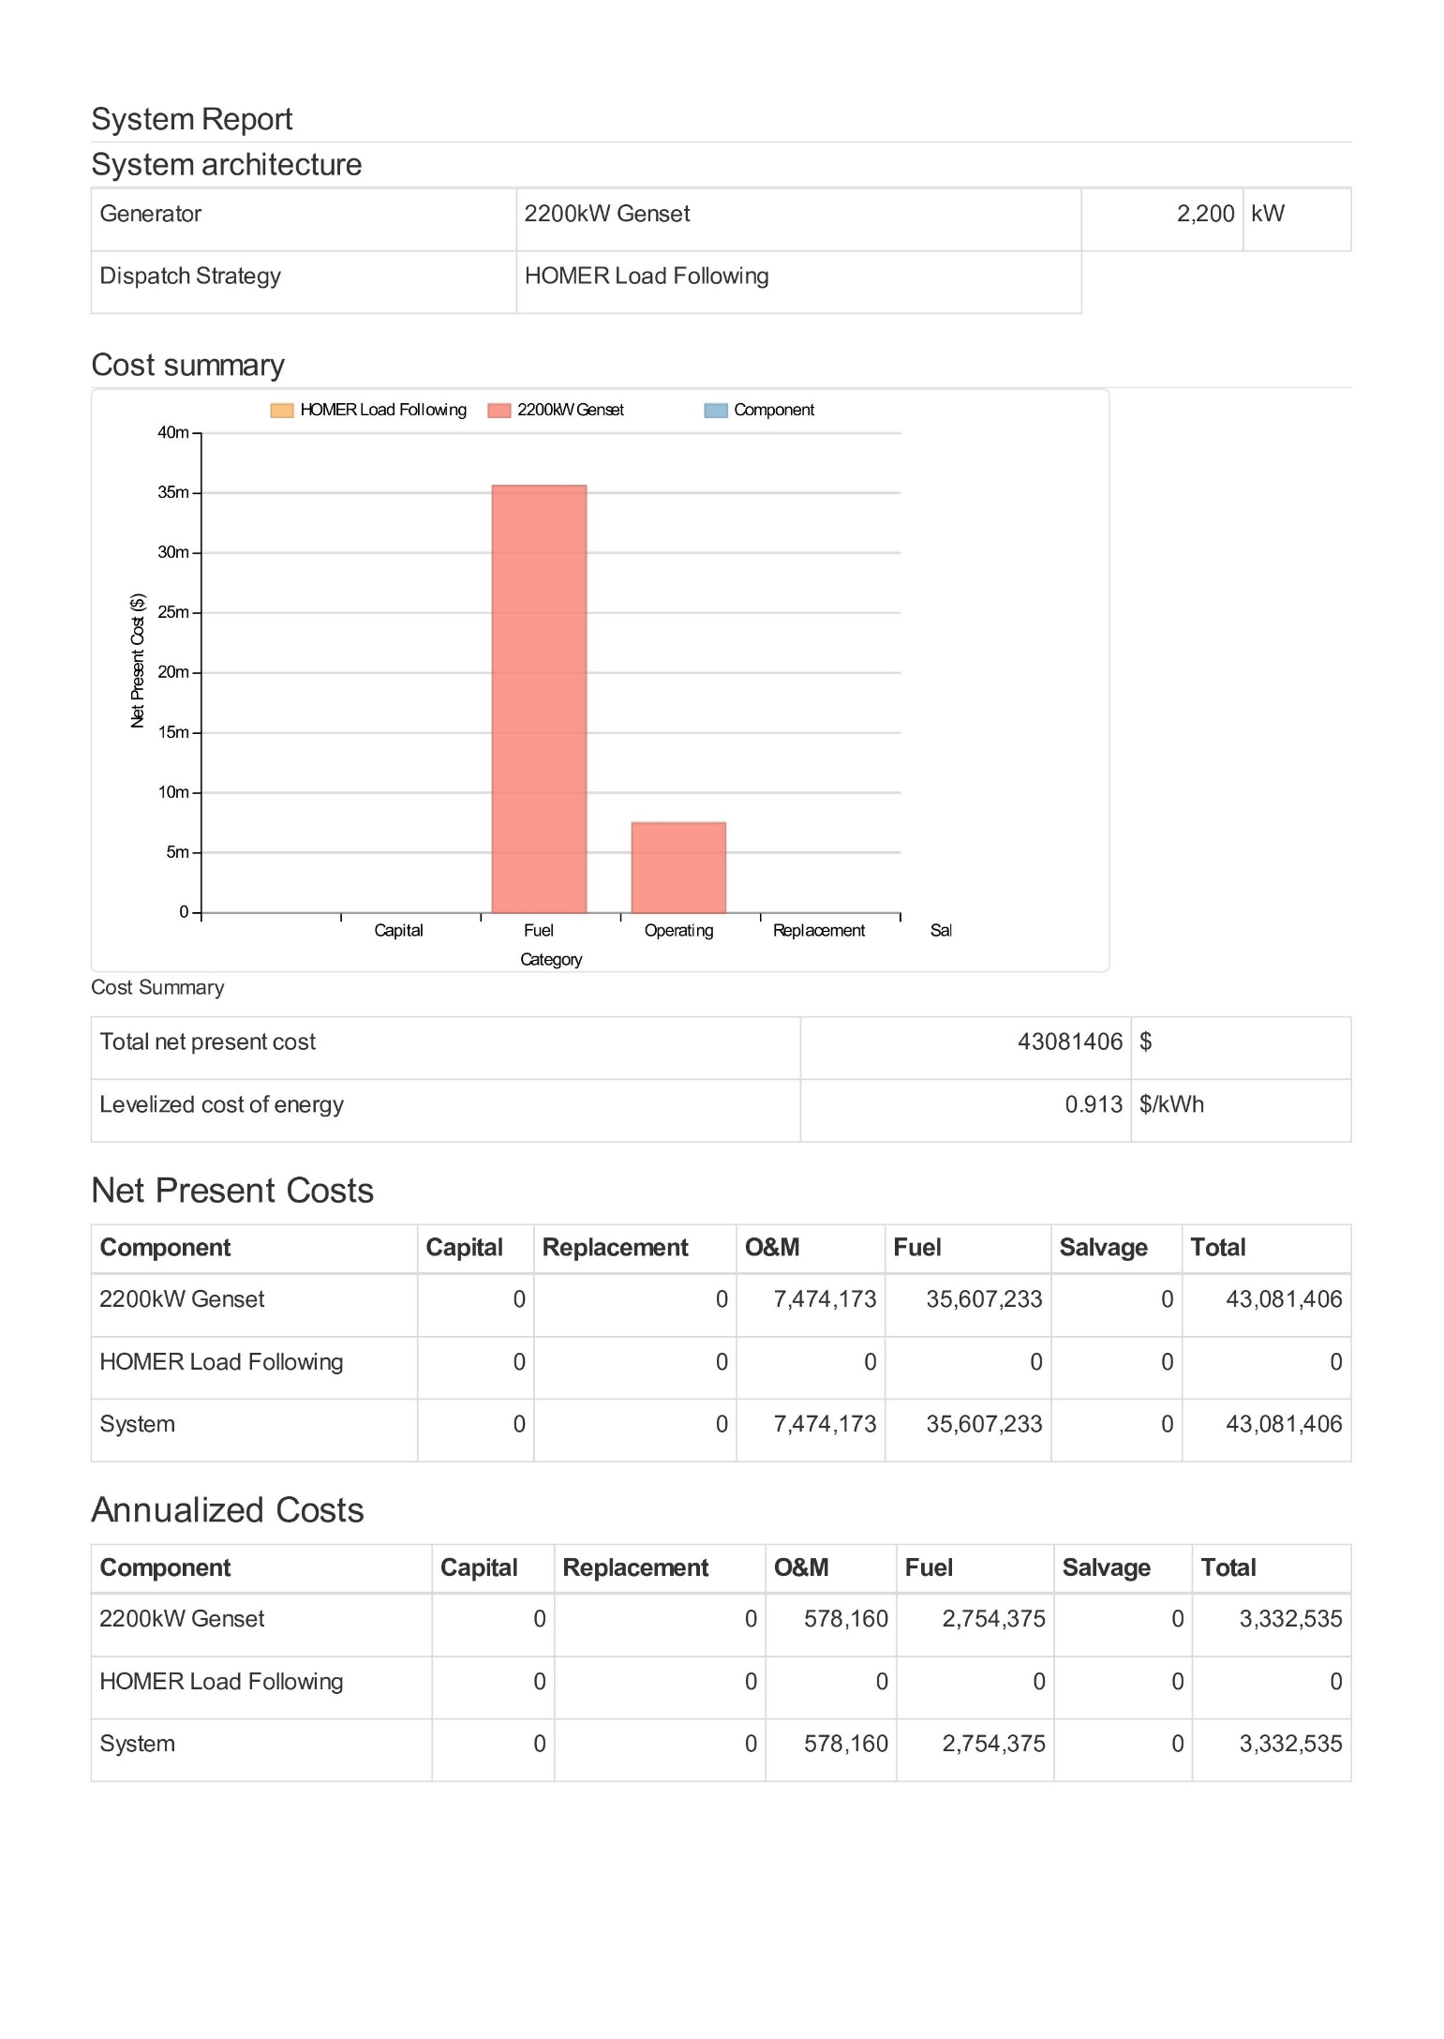

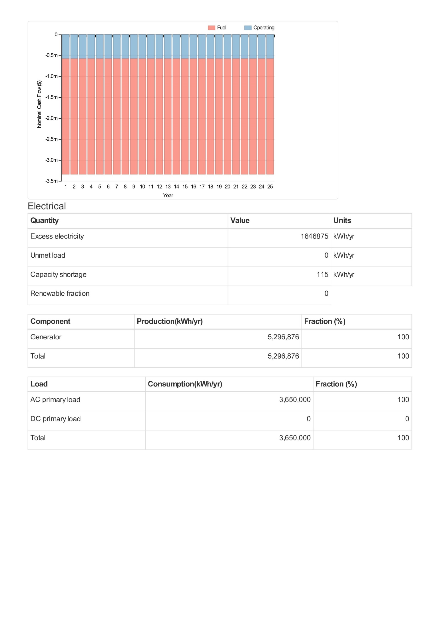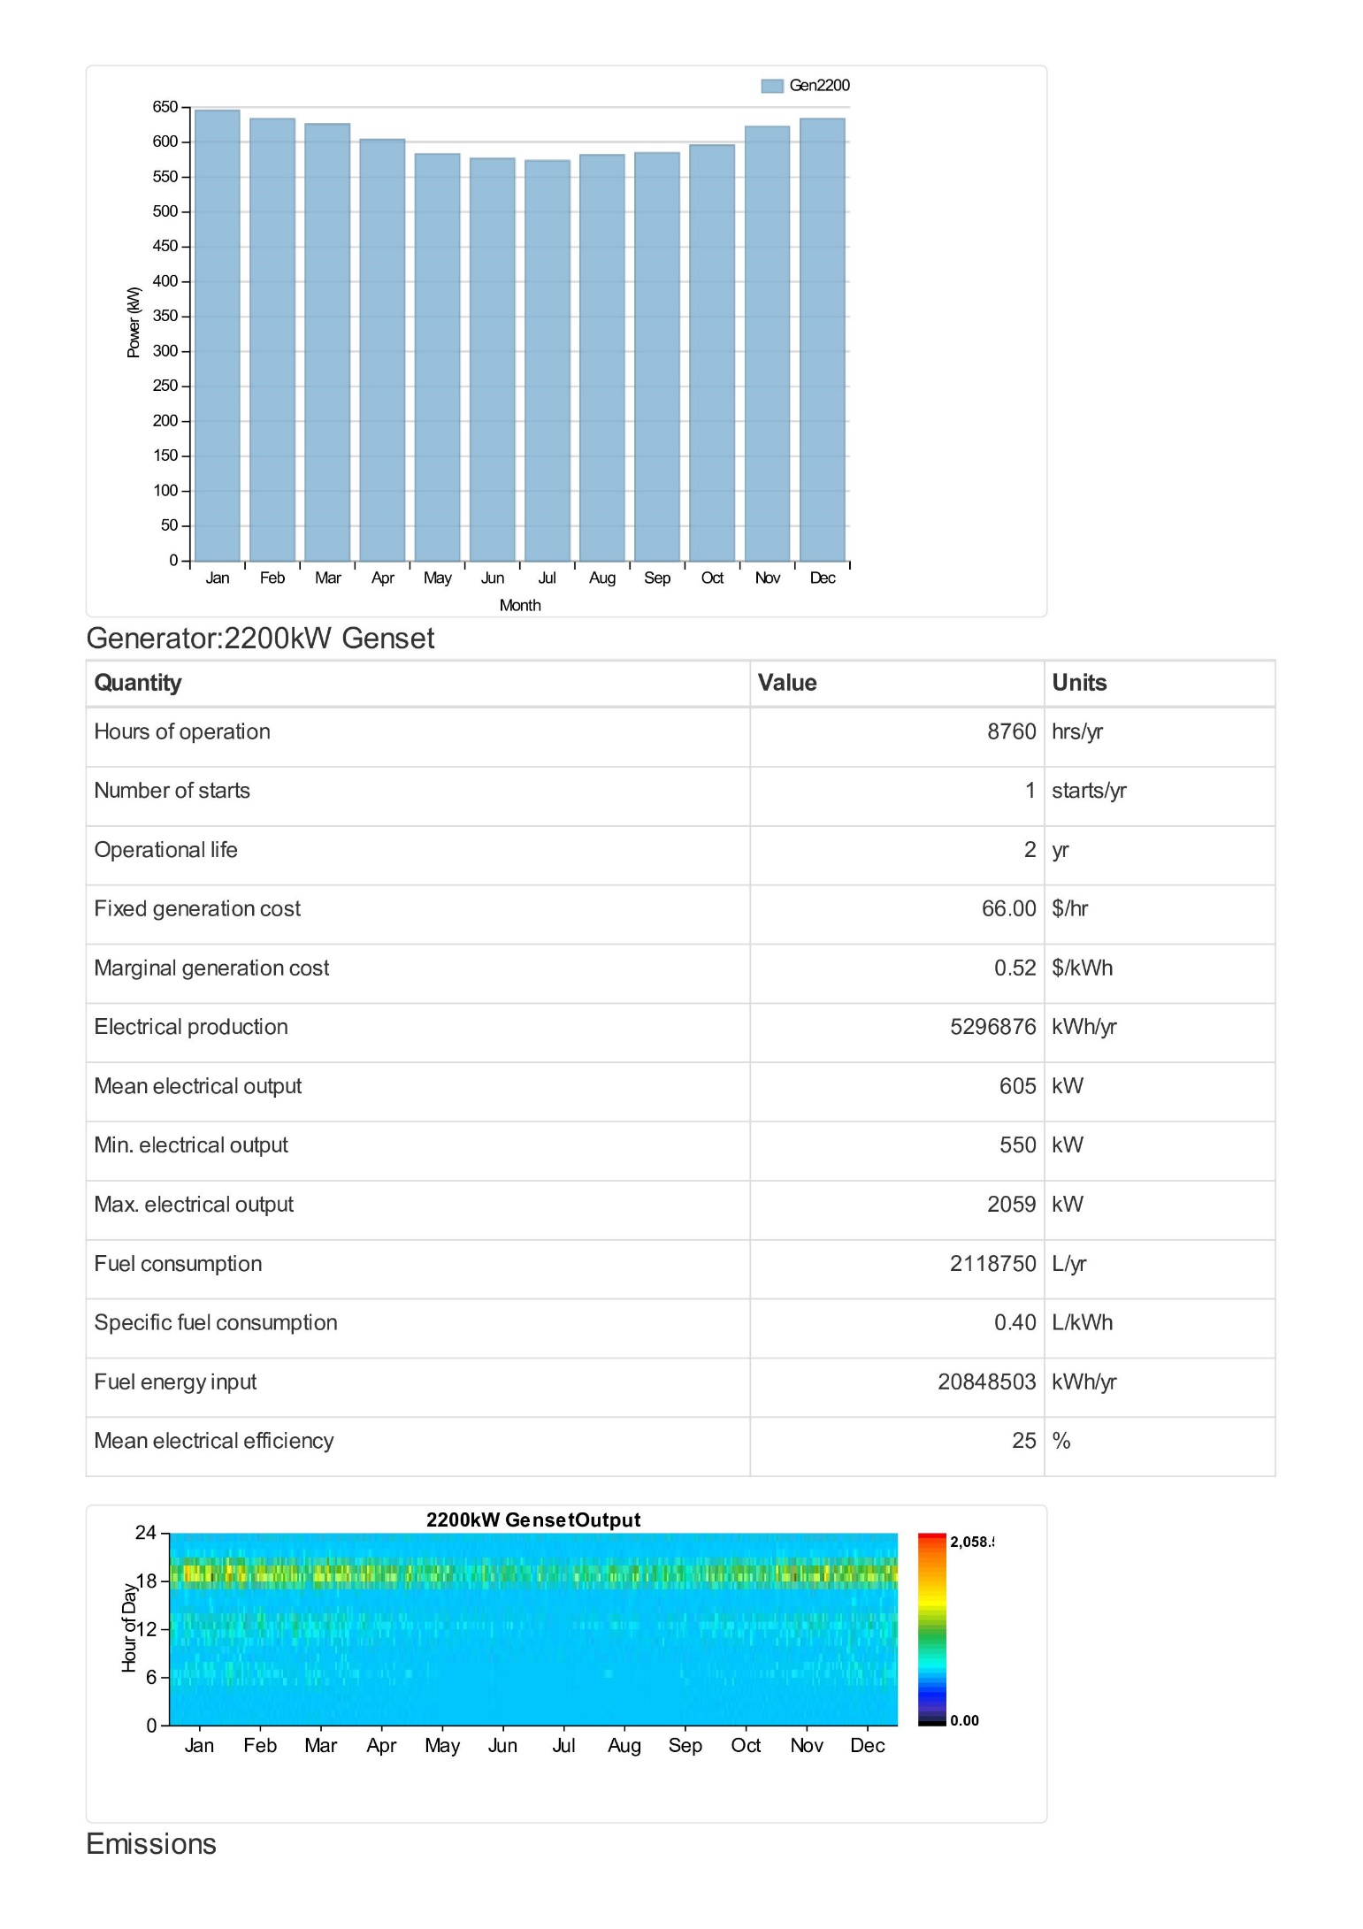

* 1. – Wind, Wave and Pumped Hydro simulation report

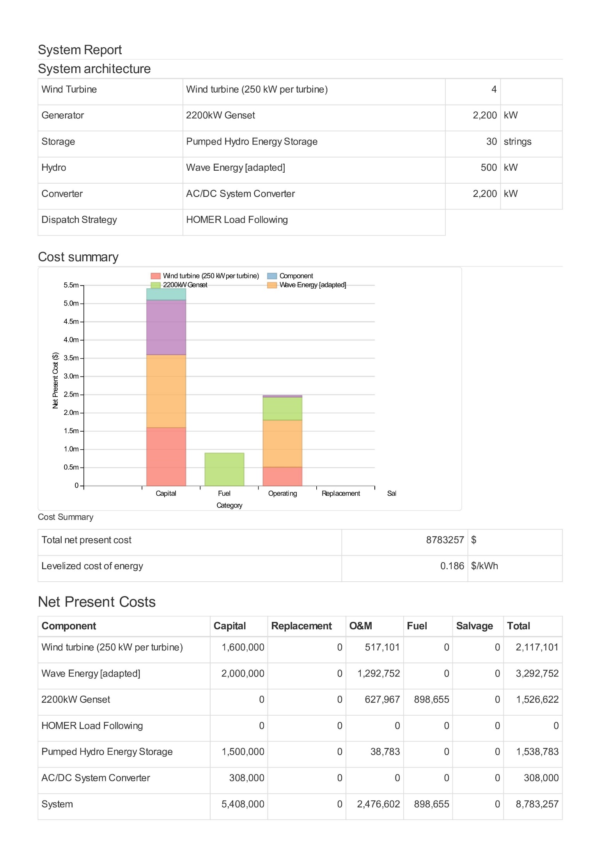

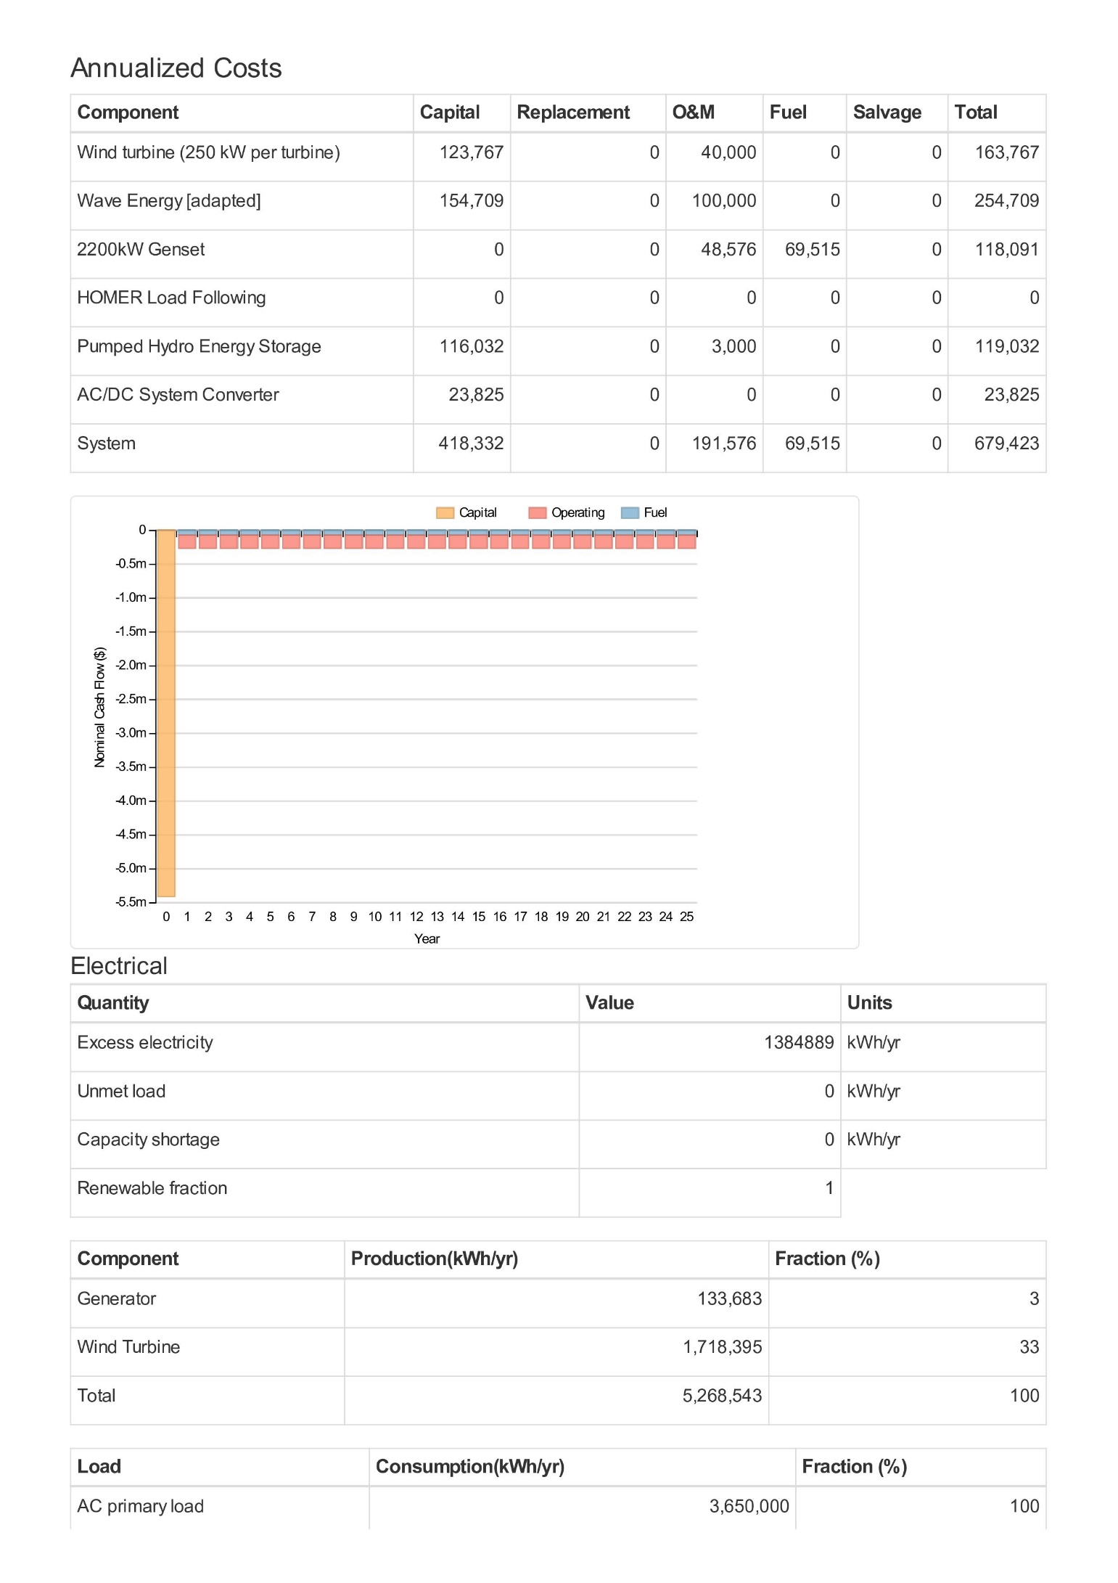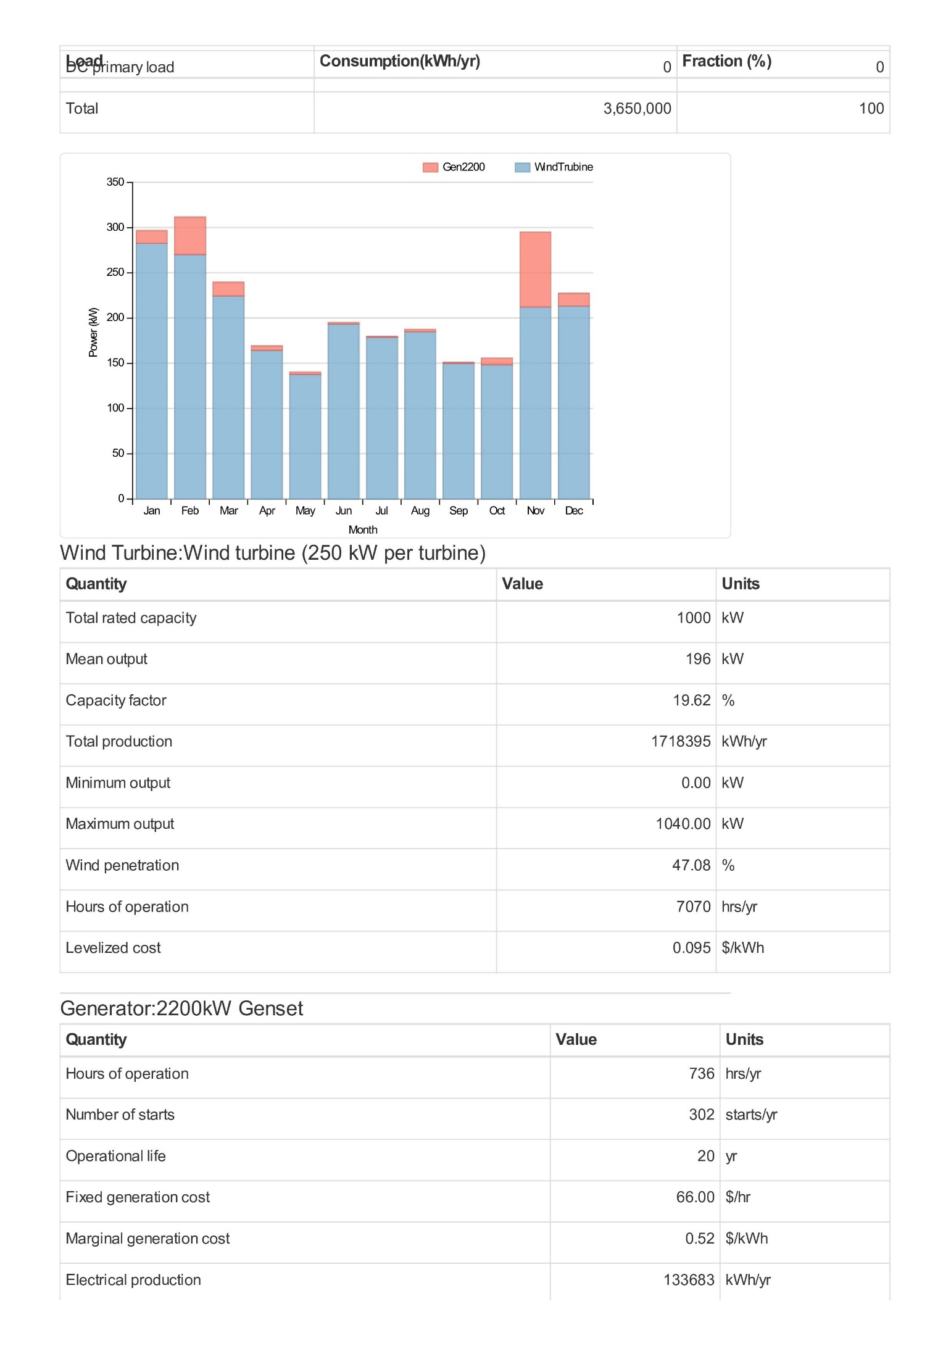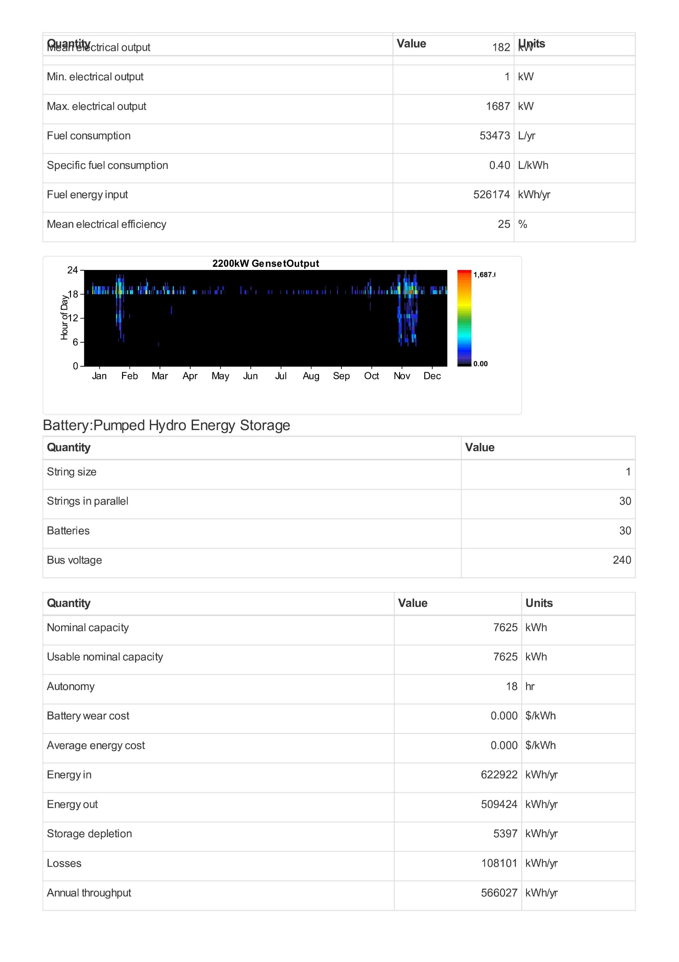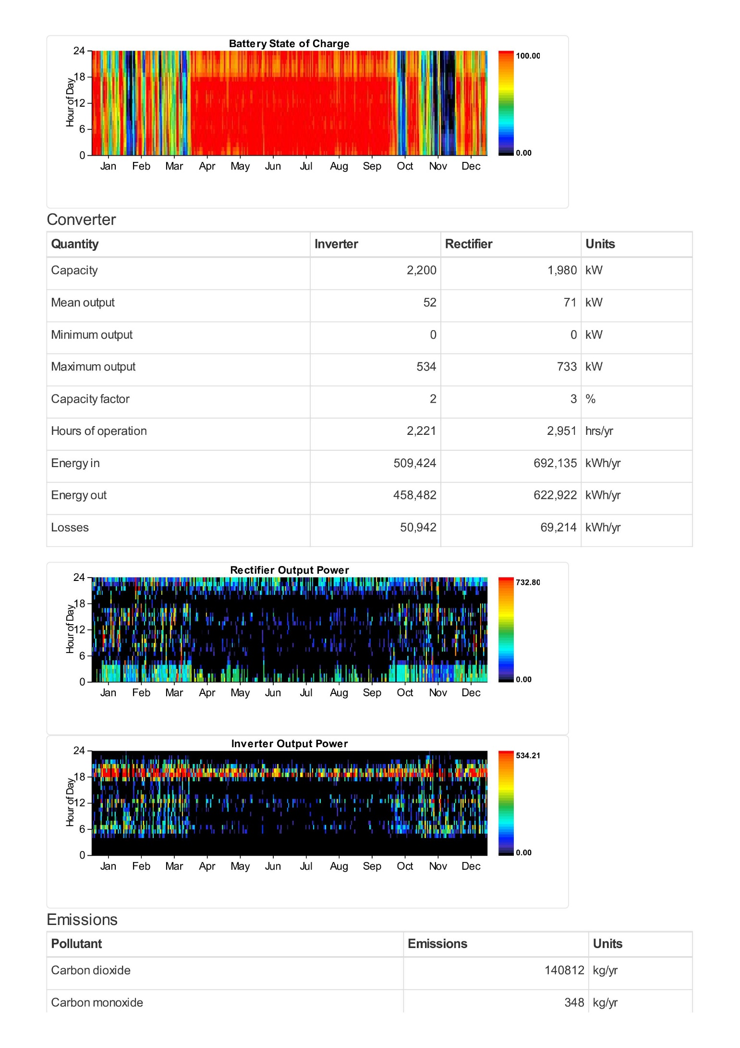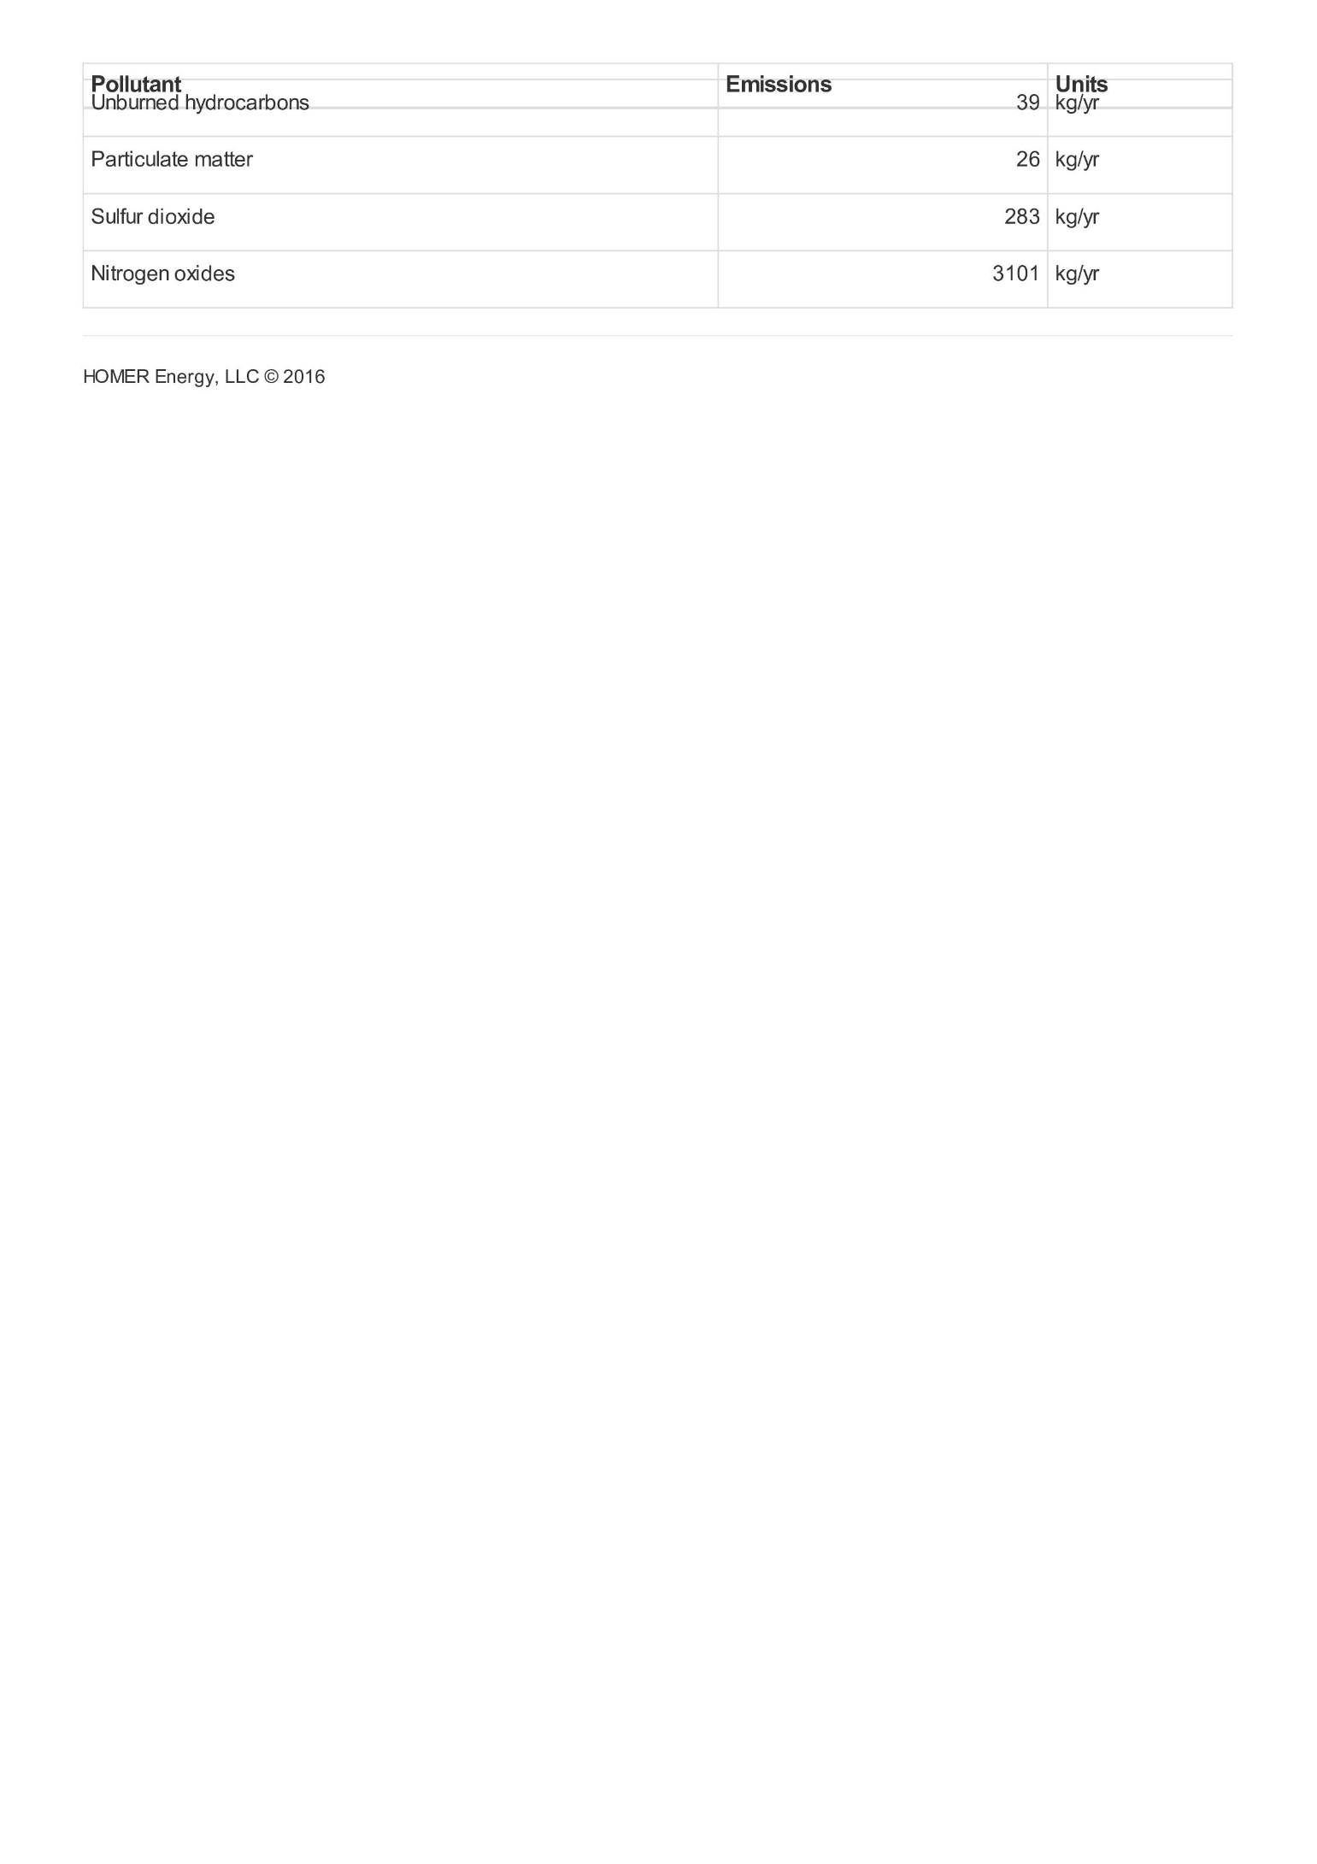

Appendix A3 – PV, Wind and Battery Storage simulation report

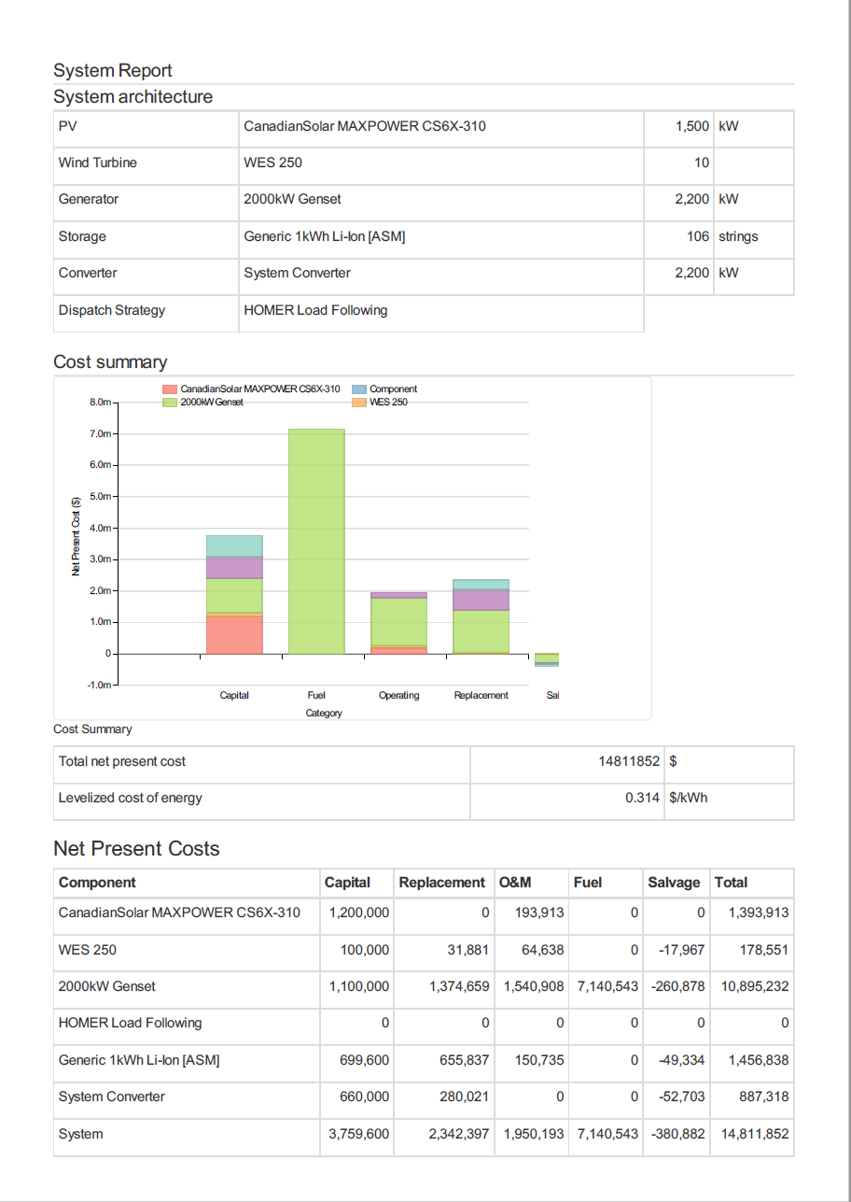

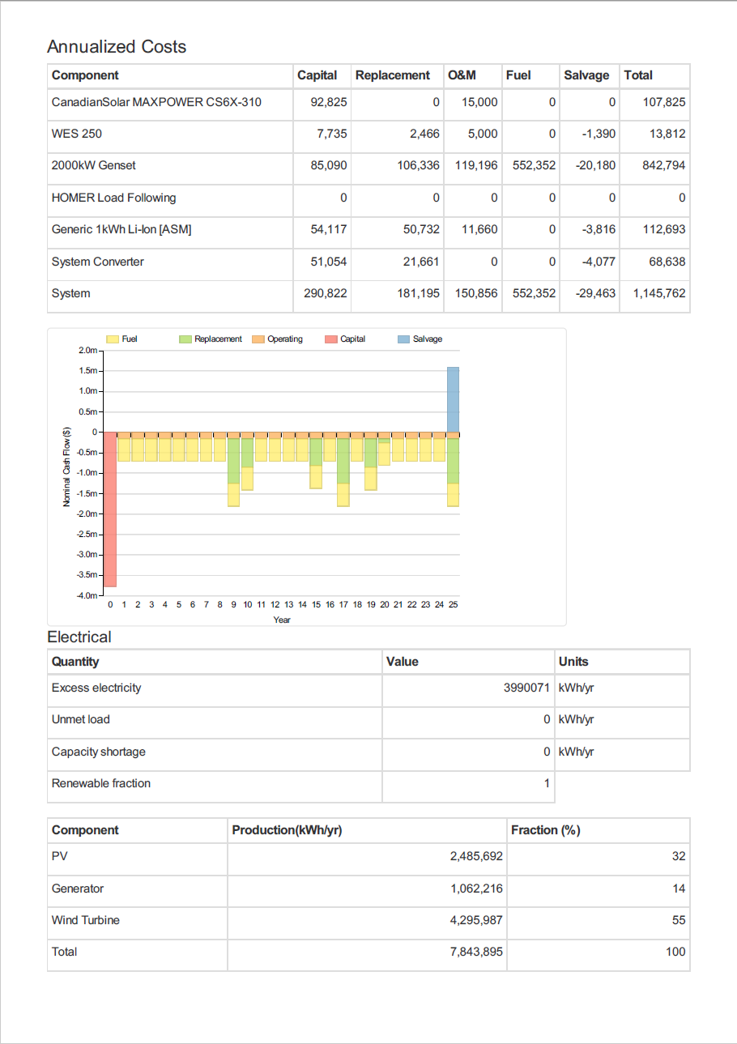

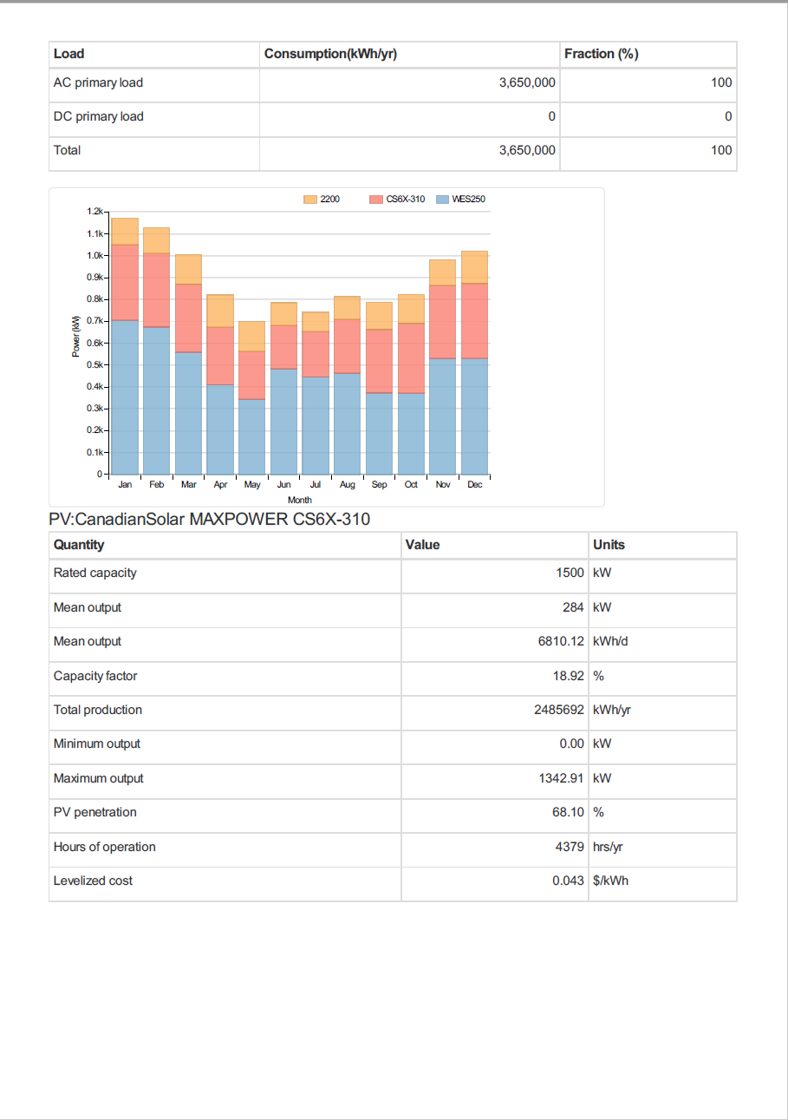

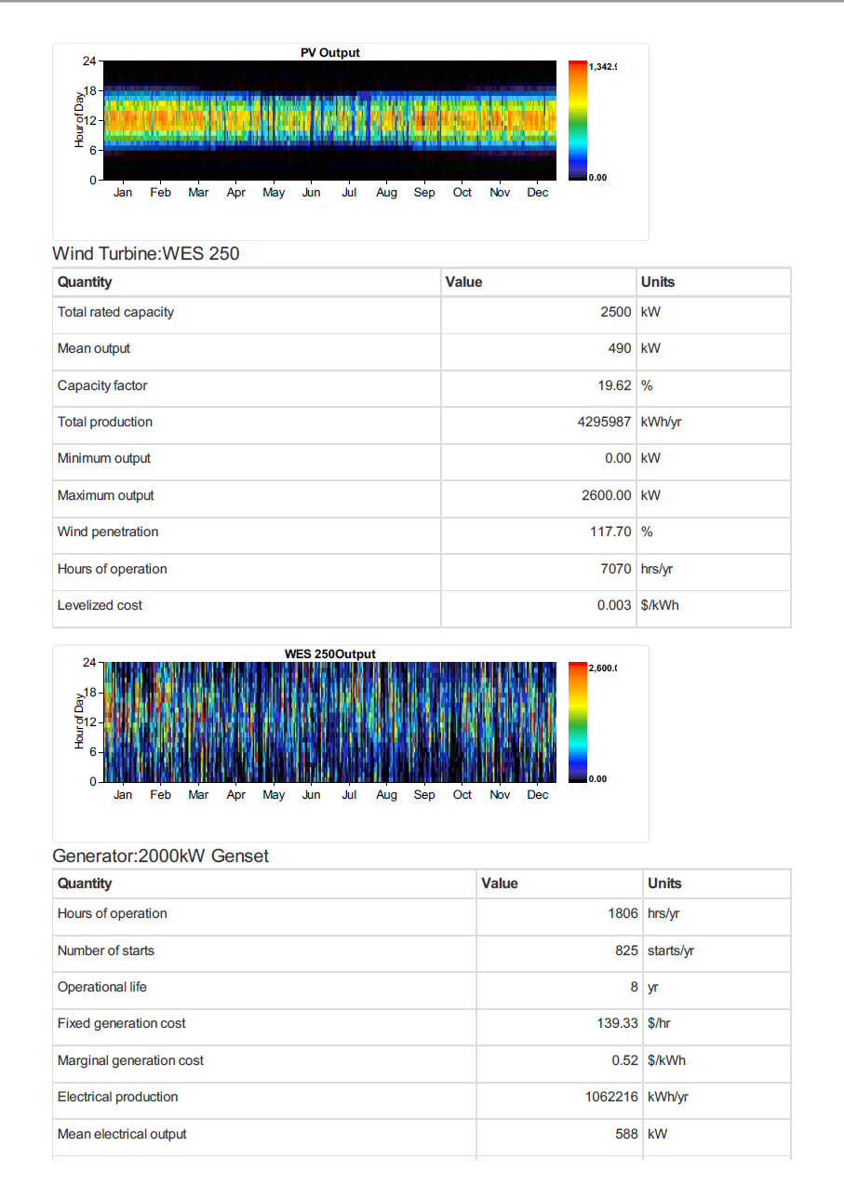

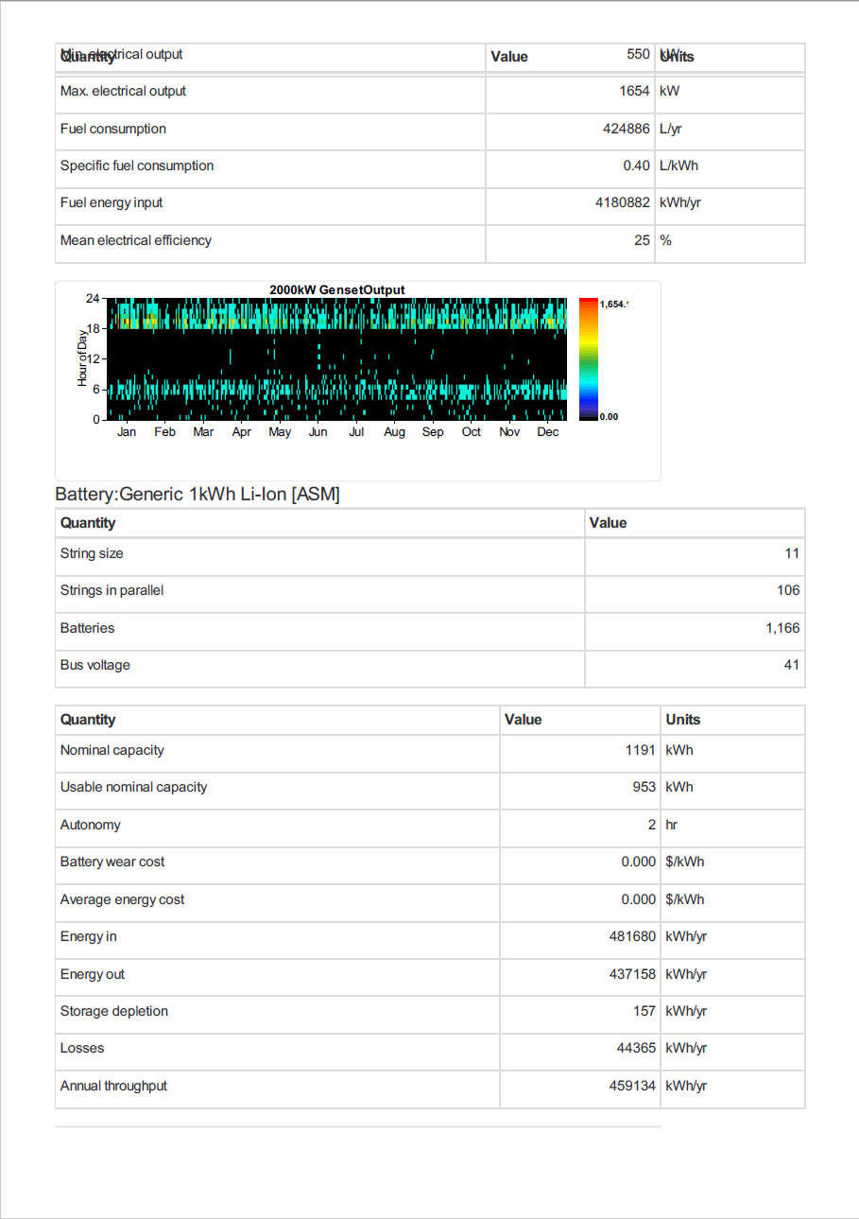

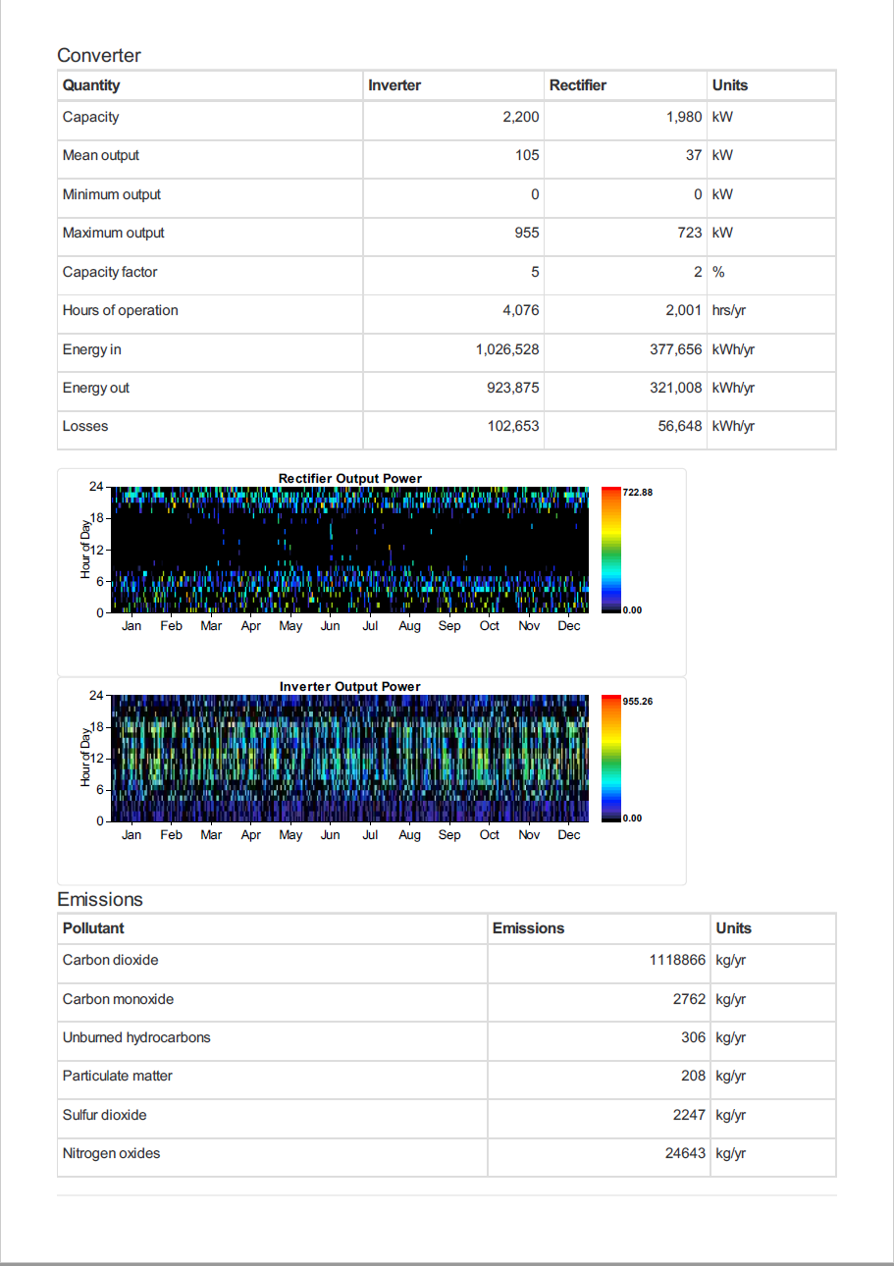

1. - Project Planning
   1. - Meeting minutes

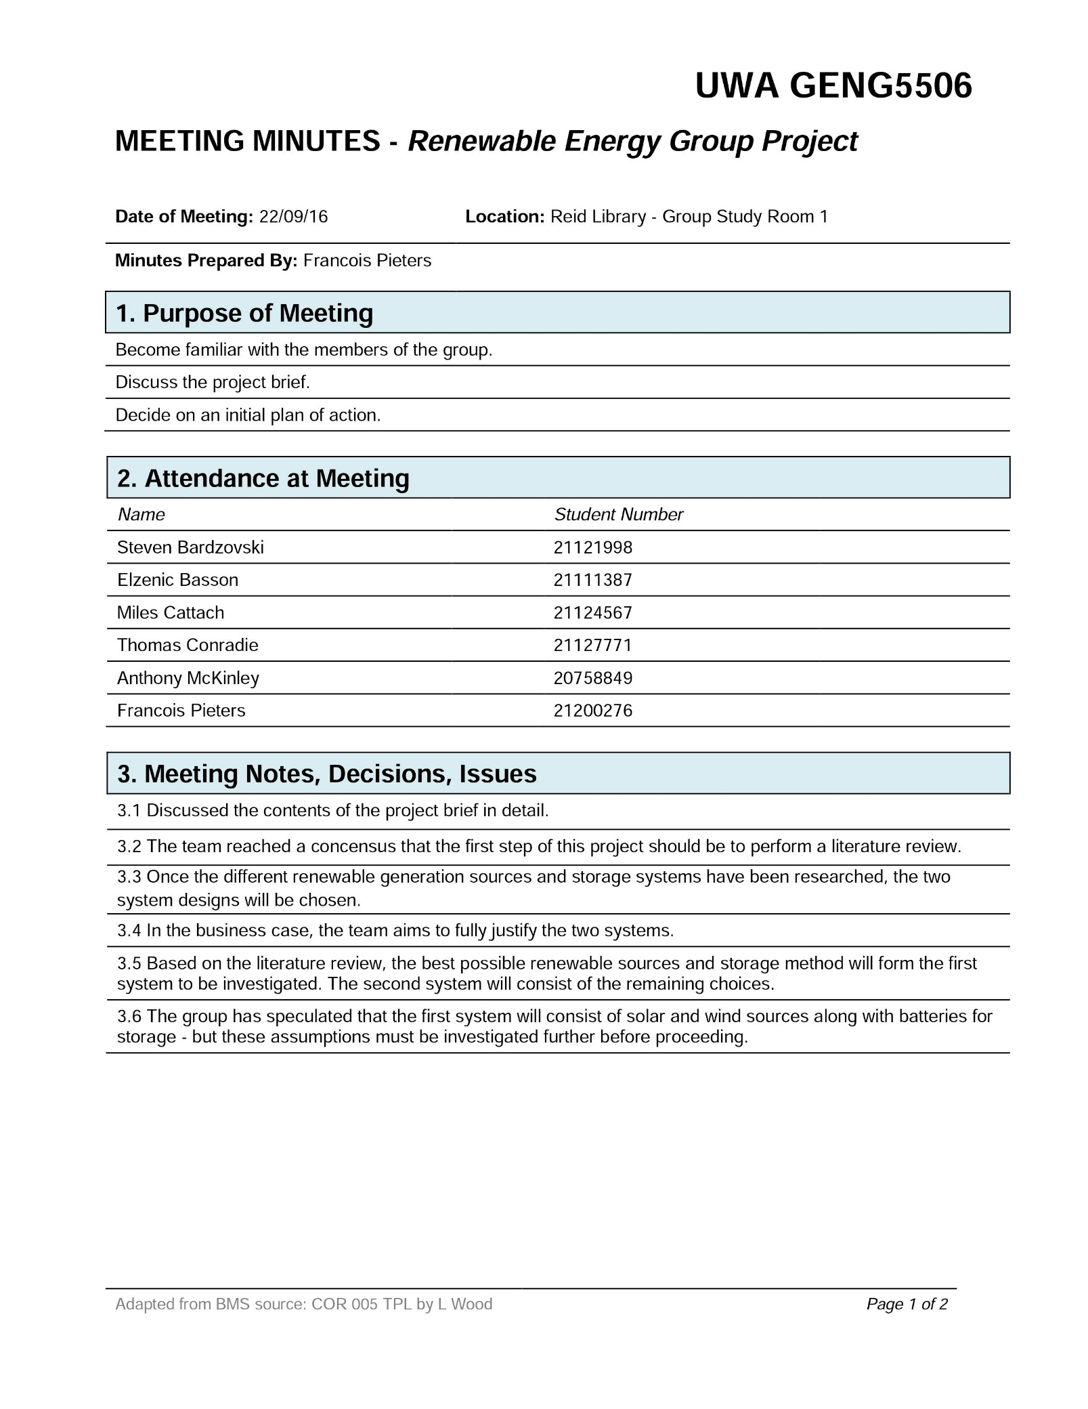

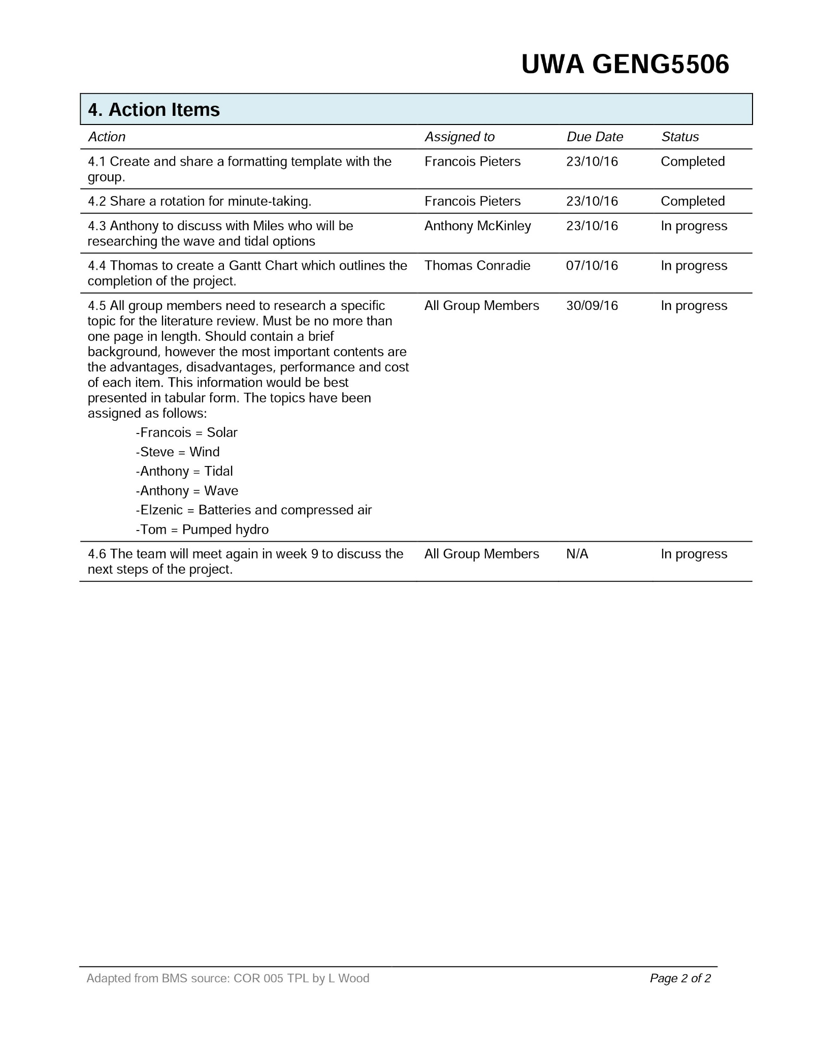

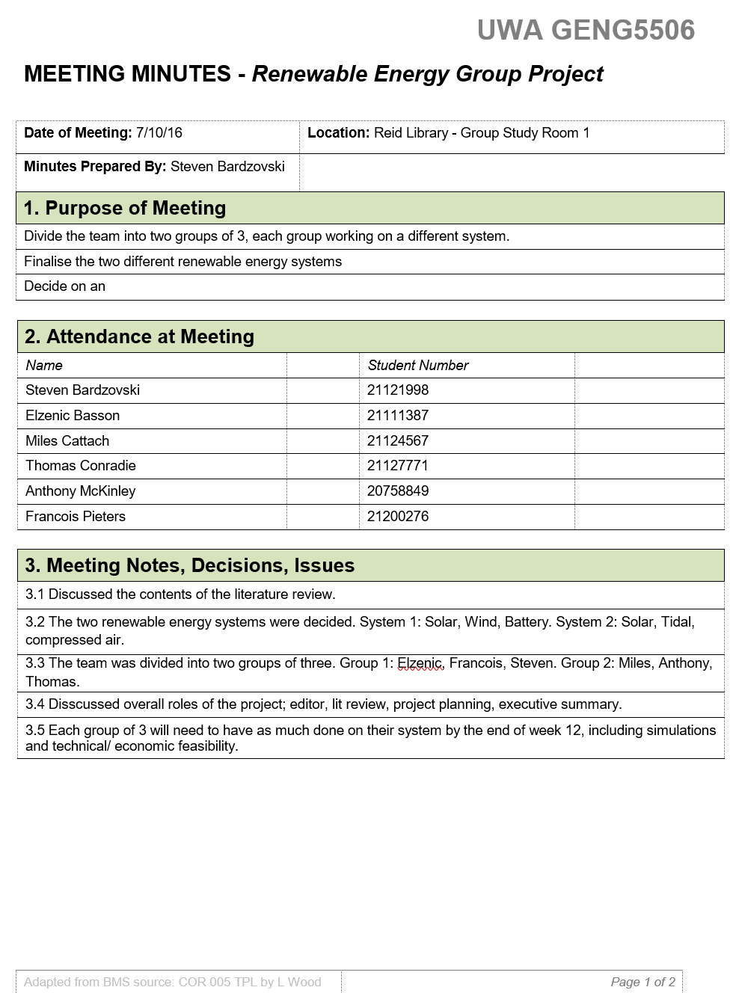

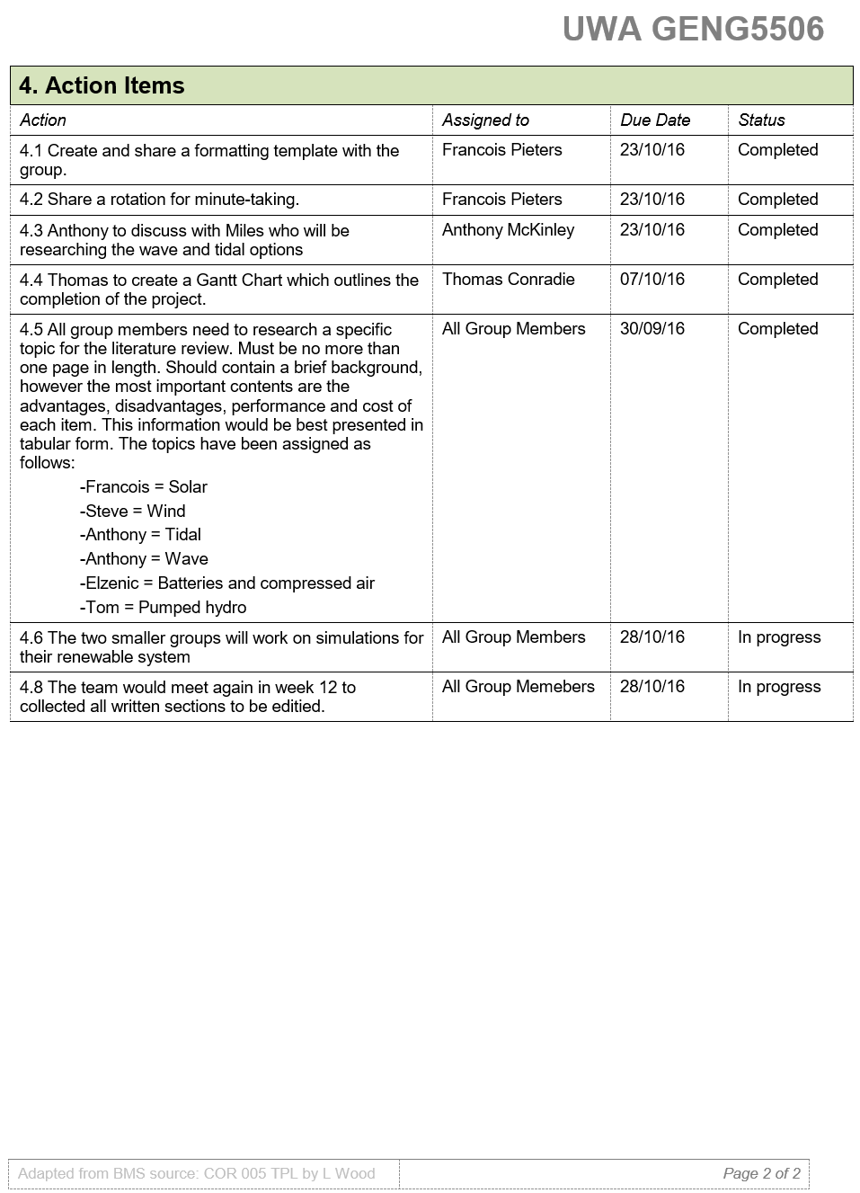

* 1. 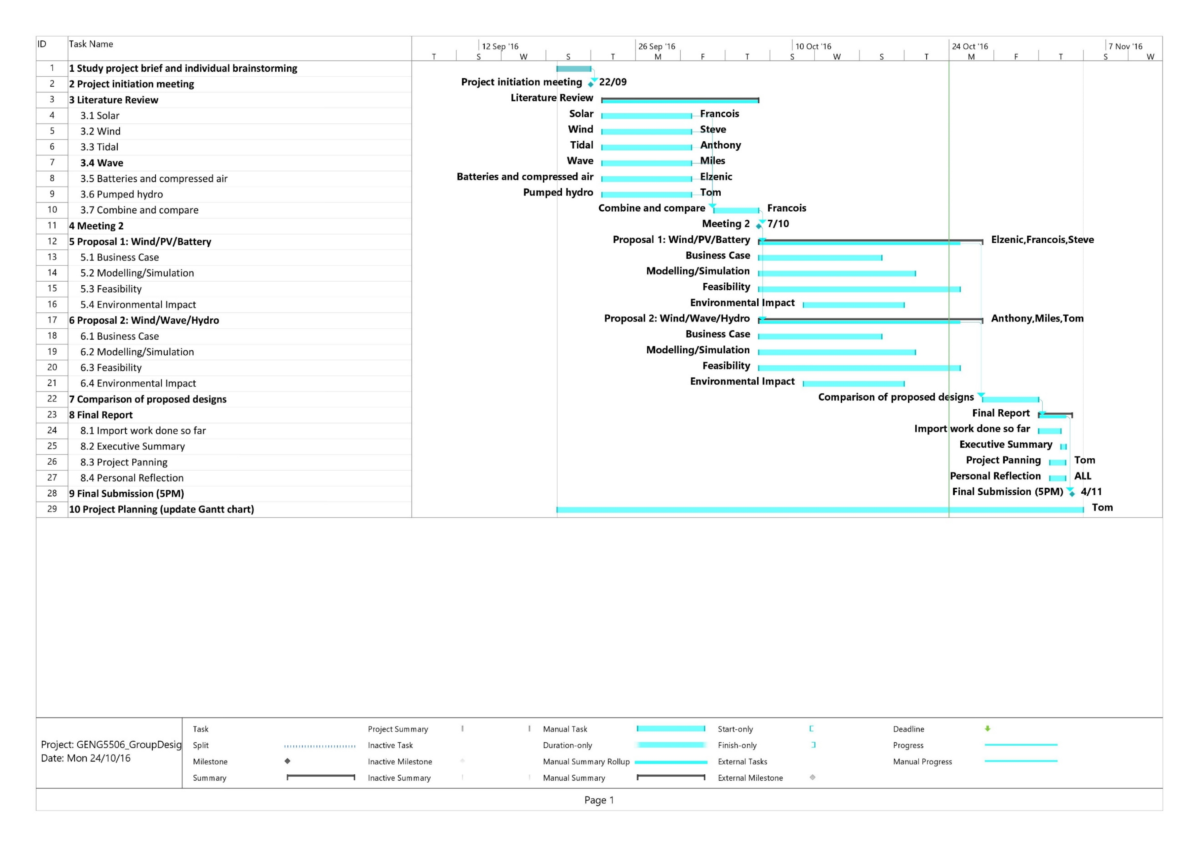 - Gantt Chart / Project Timeline